

**UNIVERSITY OF GHANA LEGON**

ACCRA GHANA

**DEPARTMENT OF COMPUTER ENGINEERING**

SCHOOL OF ENGINEERING SCIENCES

**FINAL YEAR PROJECT REPORT**

ON

**FAULT DETECTION USING INTEGRATED OPTICAL TIME DOMAIN REFLECTOMETER(OTDR) IN LONG HAUL FIBER TRANSMISSION**

PROJECT REPORT SUBMITTED IN PARTIAL FULFILLMENT OF THE REQUIREMENTS FOR THE BACHELOR OF SCIENCE DEGREE IN COMPUTER ENGINEERING

NAME OF STUDENT: **ISAAC ADZAH SAI**

INDEX NUMBER: **10615865**

NAME OF STUDENT: **RICHARD OSEI SAKYI**

INDEX NUMBER: **10608018**

NAME OF SUPERVISOR: **DR. WIAFE OWUSU-BANAHENE**

DATE OF SUBMISSION: **JULY 6, 2020**

DESIGN OF A FRAUD ALERT SYSTEM FOR MOBILE MONEY SUBSCRIBERS

By

**Isaac Adzah Sai**

(**10615865**)

And

**Richard Osei Sakyi**

(**10608018**)

Submitted to the Department of Computer Engineering in

Partial Fulfilment of the Requirements for the Degree of

Bachelor of Science in Computer Engineering

University of Ghana

**July 6, 2020**]

**Name of Student**: _______________________________________________________

Signature of Student: _____________________________________________________

**Name of Supervisor**: ____________________________________________________

Signature of Supervisor: __________________________________________________

**Name of Head of Department**: ____________________________________________

Signature of Head of Department: ___________________________________________

Declaration of Originality

Department of Computer Engineering

I certify that this thesis is my own work except where indicated by a reference. I also certify that I have read and understood the guidelines on plagiarism in the Computer Engineering undergraduate thesis handbook including the University of Ghana’s policy on plagiarism. I have acknowledged in the text of this thesis all sources used. I have also fully referenced including page numbers all the relevant texts, figures, data, and tables quoted from books, journals, articles, Internet websites, and works of other people. I have not used the services of any professional person or agency to produce this document. I have also not presented the work of any student present or past from other academic or research institutions. I understand that any false claim in respect of this thesis document will result in disciplinary action in accordance with the regulations of the University of Ghana.

Please complete the information below by Hand and in BLOCK LETTERS.

**Student Name**: ...................................................................................................................

**Index Number**: ..................................................................................................................

Student Signature: ............................................................. Date........................................

**Student Name**: ...................................................................................................................

**Index Number**: ..................................................................................................................

Student Signature: ............................................................. Date........................................

**Name of Supervisor(s)**: ..................................................................................................

Supervisor’s Signature: ...................................................... Date........................................

ABSTRACT

**FAULT DETECTION USING INTEGRATED OPTICAL TIME DOMAIN REFLECTOMETER(OTDR) IN LONG HAUL FIBER TRANSMISSION**

Wherever on this planet, hair-slender optical strands convey tremendous amounts of data from one spot to another. There are numerous alluring properties of optical filaments for conveying this data. They have excellent data conveying limits, are minimal expense, and have insusceptibility from the multiple unsettling influences that can burden electrical wires, and remote correspondence joins. The prevalence of optical strands for conveying data from one spot to another is prompting their quickly supplanting more established innovations. Optical strands have assumed a vital part in making conceivable the phenomenal development in overall correspondences that has happened over the most recent 25 years. They are imperative in empowering the multiplying utilization of the Internet.

Ghana's telcos, a model is MTN, have embraced the utilization of fiber optics for madly quick web all over the nation Ghana. With each item comes the weaknesses and understanding in them. At the point when an organization is sending information over rapidly utilizing the fiber optical link, and afterward there is a deficiency someplace inside the link, it causes a lot of issues in the transmission of that information. The internet is now the backbone of the world and when an association however large as MTN may be cut from it for certain hours , it causes a critical deficiency of cash and in the health sector loss of lives.

The second platform, a mobile application will be built and provided for the subscribers. This will be used as a secure platform for mobile money transactions. Users can file a complaint or report a number who have attempted or succeeded in defrauding them. The reported numbers will be sent to the telcos quickly for investigation and when found guilty, they will be blocked/blacklisted. The mobile application will have a broadcast receiver which will listen to incoming calls or messages to subscribers' phones. When a fraudster is detected by cross-checking the caller id with the telcos database, the subscriber will be alerted of the potential harm coming his/her way. He or she can then allow the application to permanently block that caller.

ACKNOWLEDGMENTS

First and foremost, our gratitude goes to the Almighty God for giving us strength and seeing us through this project. It is by his mercies that we are alive today.

Secondly, we would like to thank Mr. Emmanuel Baah (Compliance & Enterprise Risk Management Professional in Digital Financial Services) at MTN Ghana for taking the time off his busy schedules to meet with us and help us understand the problem at hand. Our solution is greatly inspired by what we learned from him. We also want to thank his colleague at work Sandra Sai (Mobile Financial Service Operations Controller) for helping us connect with Mr. Bonnie. We are very grateful.

We would also like to express our sincere gratitude to our able supervisor Dr. Isaac Aboagye who from the very start encouraged, guided us, provided the necessary avenue to meet with the necessary stakeholders involved in the project. Throughout numerous consultations, he was always there to assist and correct us, leading us to the right path. We are heavily indebted to you.

Our final thank you goes to our colleges at the University of Ghana, roommates, and friends who directly or indirectly contributed to this project becoming a reality. Thank you all for your support.

LIST OF FIGURES

Figures come here

# INTRODUCTION

## BACKGROUND

A typical fiber optic cable consists of thin strands of glass or plastic, also known as optical fibers. The cable can consist of as few as two strands or even two hundred, depending on the cable. Each strand is tenth the size of a human hair. Pretty insignificant, right? Wrong. Because a single strand is capable of transferring almost 25,000 telephone calls which make an entire fiber optic strong enough to carry several million calls.[[1]](Fiber%20Optics%20and%20Its%20Importance%20-%20Shireen.%20https:/www.shireeninc.com/fiber-optics-and-its-importance).  The information-carrying capacity of an optical fiber is far greater than it is for its competitors: wires, coaxial cables, and microwave links. In addition, optical fibers are inexpensive to produce, do not conduct electricity (which makes them immune to disturbance by lightning storms, and other electromagnetic signals – except nuclear radiation), do not corrode, and are of small size. The primary reason that optical fibers have very much larger information-carrying capacity than other media, is that they carry light: this might seem a trivially obvious observation but it has fundamental significance. The frequency of the light beams that travel along optical fibers is in the vicinity of two hundred trillion cycles per second (Hz)[[2]](FIBER%20OPTIC%20TECHNOLOGY%20AND%20ITS%20ROLE%20IN%20THE%20INFORMATION%20....%20https:/user.eng.umd.edu/~davis/optfib.html).

Taking everything into account fiber optics is currently the quickest and helpful approach to send information quick over significant distances and its embraced all over. Fiber optic links are introduced by laying them underground or balancing them on Power shafts. Though these technique for introducing the strands makes it vulnerable to a ton of natural harms making harms the fiber transmissions and contrarily affecting a ton of business. The current situation is the point at which there's deficiency in a long stretch fiber (about 88Km ) it is very hard to track down the flaw in minutes and for the most part requires hours or days making it fairly unacceptable to depend on.

In view of the situation is the explanation we set out on this venture to build up a coordinated framework that distinguishes the issue in a long haul fiber transmission.

## PROBLEM STATEMENT

Many sophisticated algorithms and designs have been invented to help the activities of telecommunication operators and fiber optic users to accomplish different purposes but some of the operators do not have some of these information technology systems designed purposely for the detection of long haul fiber transmission but rather for shorter distances. Some of the systems have become obsolete and cannot compete with the increasing challenges associated with. When there is a flaw in fiber network transmission in a major telecom organization, for example, MTN a ton of organizations in Ghana gets influenced. For instance the downlink of MTN Mobile money and the web by means of cell phones ( both use fiber transmision in its work ) . We as a whole know these 2 impacts on the model above alone can cause extraordinary misfortune in a people's bussiness and in a roundabout way influence the health sector and numerous different sectors since passing on of enormous information data is a necessity now.

## MOTIVATION

There was a predicament a few months back where most mtn clients couldn't send or receive money on the mobile money platform because of an instance of an issue in the long haul fiber transmission. In this period a great deal of cash was lost by MTN and made their framework powerless against attackers. It required around 3 days to get it settled . Despite the fact that they discovered the flaw , they ddn't get it resolved quick enough. This is the place where the inspiration came from to take the undertaking to have the option to identify the issue in a long haul fiber transmission utilizing integrated optical time domain reflectometer.

## PROJECT OBJECTIVES

The objectives of this project are to develop:

1. An artificial intelligence model that verifies user details using multiple data sources and artificial intelligence.
2. A Transaction Processing Monitor (TPM) that routes requests to various databases to get relevant data.
3. A web application system to aid mobile money platforms quickly register and track users.
4. A mobile-based system that prevents fraudsters from getting in contact with users by verifying anonymous calls using the web application

## RELEVANCE OF PROJECT

The project seeks to provide the following benefits:

1. Alert user of mobile money fraud activities.
2. Provide a platform for service providers to cooperate in tracking fraud activities and fraudsters.
3. Users can easily report fraud activities to the Mobile Network Operators.
4. The application can also be used for safe mobile money transactions.

## OUTLINE OF THESIS

This thesis is divided into five parts. Chapter 1 of the thesis is mobile money platform details, benefits, and challenges to it. It also focused on the definition of problems and targets. Chapter 2 discusses related technologies with a view to explaining this Job. This also includes the research suggested, and its scope. Chapter 3 details the concept of The method of designing the proposed program. It also sets out requirements and Design and development specifications required. Section 4 deals with the implementation and device checking for confirmation of its features. It also tests the evidence from assessments and success assessment. The thesis closes with Chapter 5 stressing the main achievement of the research and the probability of recommendations for more research designed to improve machine performance.

# LITERATURE REVIEW

## INTRODUCTION

This chapter examines related works undertaken on the management of fraud activities. It looks at the limitations of the existing systems and approaches as well.

## REVIEW OF RELATED WORK

A number of attempts have been made over the past few years to combat fraud activities by mobile money service providers. This section highlights different components and algorithms used by the approach as well as the different experiments performed with the aim of investigating fraud activities.

### REGULAR EXPRESSION MATCH BY MTN GHANA.

MTN Ghana has implemented an SMS check that reads SMS being sent via its network. This system checks the content of the SMS and blocks it from being sent if it has the same or similar structure as the official mobile money message received from legitimate money transfers.

The system comprises a regular expression match layer to detect the structure of the message and a layer of artificial intelligence to detect the context of the message and prevent it from being sent successfully. The limitation of this system is that it only checks for the SMS sequence for mobile money fraud activities.

### TRUECALLER APP

The data is crowd-sourced from the millions of users who have downloaded the truecaller app on their smartphones. As part of the end-user agreement, the truecaller app asks the user to allow access to the user's address book/contacts on the smartphone. This data is then uploaded by the app to the company's servers[[9]](https://www.zotero.org/google-docs/?cnJDUp). This data collected is used to identify the names of new callers or message senders. Another feature of truecaller is that users can report numbers as spam numbers and every user will be alerted of the status of that number[[10]](https://www.zotero.org/google-docs/?TWgbVz).

* + 1. **SOCIAL ENGINEERING**

Anonymous calls and text messages from fraudsters: Fraudsters call mobile money subscribers that they have deposited money into their accounts mistakenly and therefore they should transfer them back to them. These are normally detected as false claims after the mobile money account balances are checked[[34]](https://www.zotero.org/google-docs/?dJFOhU).

False promotion: Some mobile money subscribers are deceived to transfer money to fraudsters after they have been told to authorize cash out transactions because they have won mobile money promotion. Fraudulent mobile money subscribers send fake messages to their agents either from their own handsets or generated from computers as genuine messages by the recipients; they pay the money fraudsters but later on detect that they were fake.

Scam: Fraudsters call to deceive subscribers that they are to deliver goods from abroad or from a close relative under false pretext. Some fraudsters call and ask for specified amounts to be deposited into a mobile money account in exchange for goods from relatives or friends from abroad.

False cash out SMS: Fraudsters send false cash out messages to merchants for authorization of which the physical cash is issued by the merchant to the fraudster without the equivalent e-cash.

To combat this various fraud activities, a social awareness video has been created to inform the general public through social media circulation and television broadcasts.

## SCOPE.

### CONVOLUTIONAL NEURAL NETWORK

Convolution Neural Network (CNN), has deep feed-forward architecture and has an astonishing ability to generalize in a better way as compared to networks with fully connected layers. CNN describes the concept of hierarchical feature detectors in a biologically inspired manner. It can learn highly abstract features and can identify objects efficiently. The CNN is considered above; other classical models. First, the key interest for applying CNN lies in the idea of using the concept of weight sharing, due to which the number of parameters that needs training is substantially reduced, resulting in improved generalization. Also, the classification stage is incorporated with the feature extraction stage, both using the learning process[[11]](https://www.zotero.org/google-docs/?v1UXlk).

Secondly, it is much more difficult to implement large networks using general models of artificial neural networks (ANN) than implementing in CNN. CNNs are widely used for image classification, object detection, face detection, speech recognition, vehicle recognition, diabetic retinopathy, facial expression recognition, and many more. A new learning technique, ADAM proposed has also been elucidated. In addition to that, there is a computer learning rate for every individual parameter.

### OPTICAL CHARACTER RECOGNITION

Digitizing paper documents generally involves creating a bitmap image of the paper document using a scanner or similar device and then storing the bitmap image in a computer system. To retrieve and evaluate bitmap images, the computer must recognize characters within the bitmap image created by the scanner. Character recognition techniques, for example, optical character recognition (OCR) techniques, are generally used to convert images of characters, usually provided to the computer system in some standard format, such as, for example, the tagged image file format (TIFF), into machine-legible coded form of those characters, such as, for example, ASCII or Unicode[[12]](https://www.zotero.org/google-docs/?Ywsuwj).

## PROPOSED WORK

The proposed work involves a web application that made use of an implementation of a convolutional neural network for ID card classification during registration. Another layer that uses extracted text data using optical character recognition and automatically fills the registration form. The ID information is linked with the user’s data for easy tracking. All these are embedded in a web application that allows telecommunication company users to blacklist fraudsters when identified.

By using Mobile Broadcast Receivers, incoming calls are screened to check for potential fraudsters. The Mobile Application uses data it receives from the web application to help prevent subscribers from these fraudsters. This chapter gives a review of systems available in accordance with detecting spam calls via a mobile application and also the manner of data extraction and registration for mobile money users.

# SYSTEM DESIGN AND DEVELOPMENT

## INTRODUCTION

In this chapter, we discuss how the system is built to achieve the desired purpose and results. The details of the methodology used are spelled out. Everything related to the mobile application, web application, and the AI models design is included.

## OVERVIEW OF SYSTEM

The system comprises 2 major units which are mobile application and web application.

The mobile application was built with Flutter allowing it to run on both IOS and Android devices. However, the functionalities that are specific to the native platform were developed in Java and Swift for Android and IOS respectively. The mobile application serves as a means for subscribers to access the system. It communicates with the web application using the HTTP protocol over a RESTful API.

The web application, on the other hand, was built with the PHP Laravel framework. It connects with a PostgreSQL database server for storing data. It uses the Redis server for the caching of data. It interacts with the AI models your background processes. It also has a TMP script to connect to external databases for data collection. The web application provides a console and web interface for administrators to use to configure and manage the system. The AI models were developed in python but were runnable on the server as a background process.

Figure 4.1 identifies the overall structure of the system, the subsystems, and their relationship and interactions.

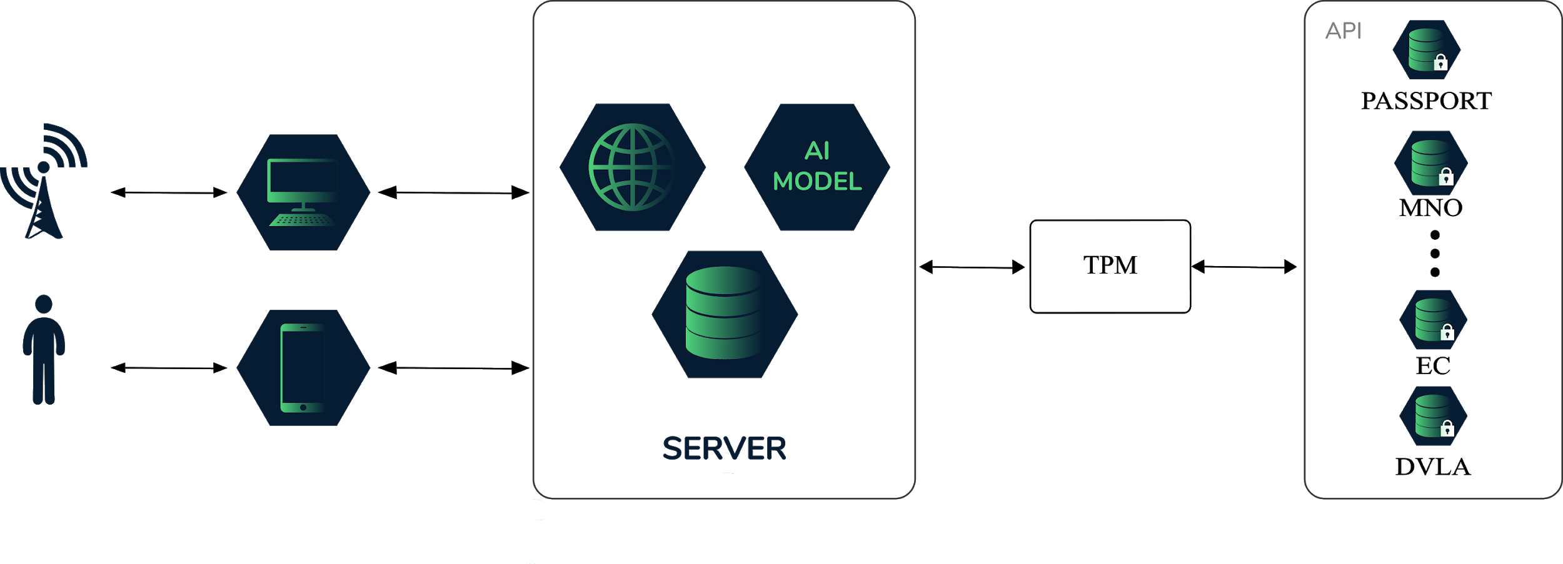

## FUNCTIONAL AND NON FUNCTIONAL REQUIREMENTS

The development of the system could not be possible without clear extracting and noting the requirements it should meet. This was done and categorized into two main groups Functional and Non-functional. In the next section, they are discussed to length.

### FUNCTIONAL REQUIREMENTS

The mobile and web application are based on the following requirements:

1. The system will allow the upload of images or snapshots from a camera.
2. The system will be able to predict the type of ID card.
3. The system will be able to extract text relevant data from a photo of an ID card.
4. The system will link user data with the user’s ID card.
5. A user will be able to block a caller id
6. A user will be able to report a fraud issue
7. The system will be able to detect an incoming caller id and provide the status

### NON-FUNCTIONAL REQUIREMENTS

1. Usability: The user must be prompted of the fraud status of a caller id
2. Reliability: Data from low-quality photos or defaced IDs will have very low accuracy
3. Performance: Depending on accessibility the user gives the system to the phone functionalities.
4. Supportability: The system is web-based and android based.

## SYSTEM DESIGN PROCESS

The process taken to develop and design the mobile money fraud alert system is described in this section.

### FLOW DIAGRAM

The flow of information and how the mobile application works are illustrated in the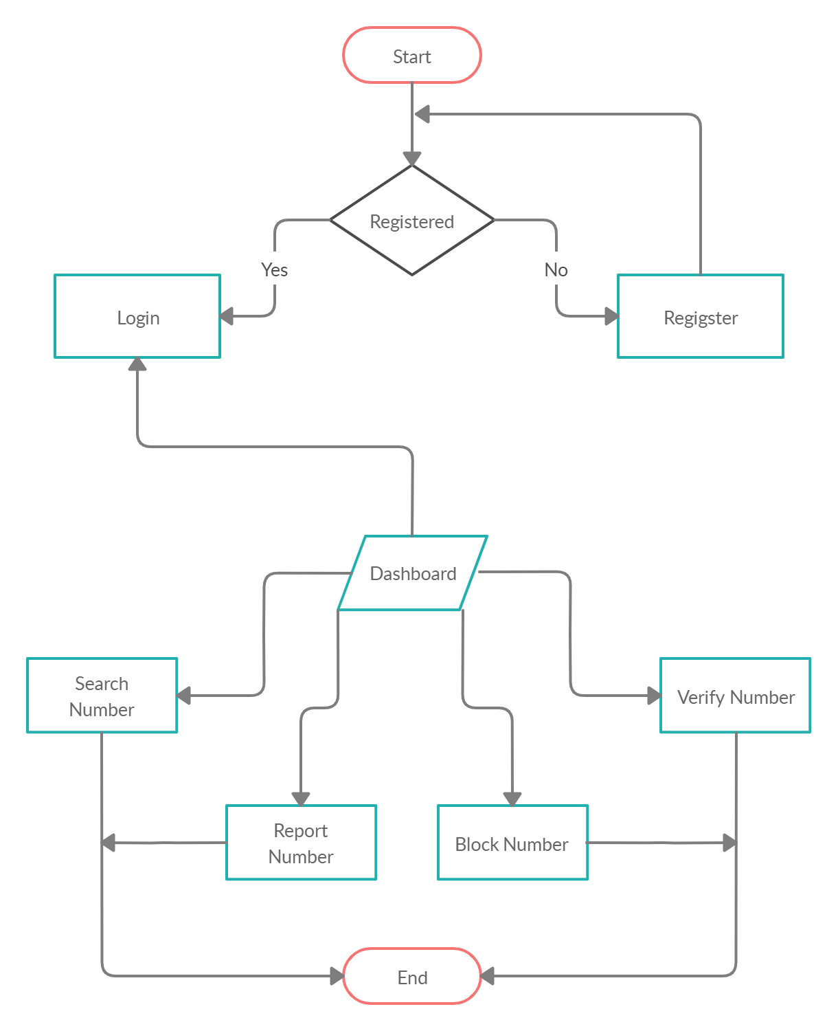figure below

The mobile money subscriber can start using the application by registering. Without registering, they can not proceed further with the use of the mobile application. After successful registration, they then login to their account dashboard.

At this stage, they can perform some number of actions like searching a number in our database, report fraud attempts, and block fraudster’s number. However, verify incoming numbers from phone calls is automatically activated in the background as a service.

The Figure below shows the detail of the number verification system. When a new call is detected using the native broadcast receivers, it starts a background service that makes an HTTP call with the incoming phone number to a REST endpoint on the web application. The number is searched for in the database. When found, the status of the user is displayed else it tells the user that that user can not be found.

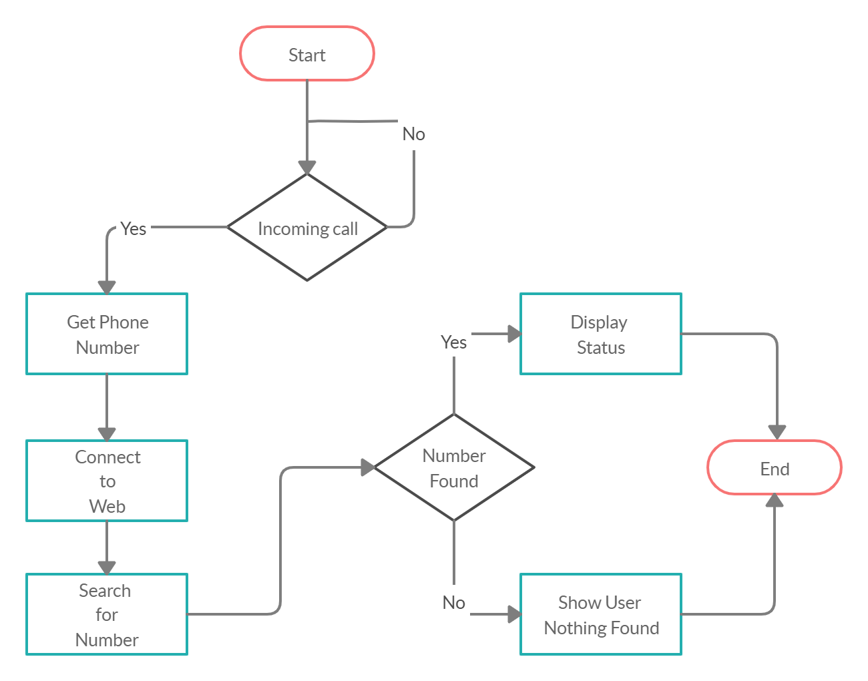

### BLOCK DIAGRAM

FIGURE 4.2: Shows the entire system and how the various components communicate with each other. The web application lies in the center, it connected to every component and serves as the master having the application logic. The subscribers mobile depends on the web application to make predictions, authenticate users, and perform other tasks that are not directly related to the device. The web application controls the creating, reading, updating, and deleting of data with the help of the database to be precise, PostgreSQL. It also controls caching for authentication with the use of a Redis server. Finally, it makes predictions by running the AI models in the background to retrieve the result and interpret it.

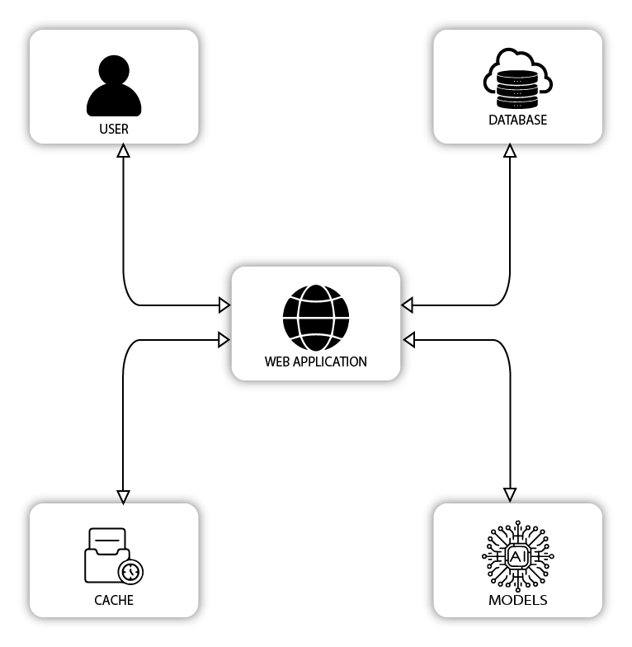

### SEQUENCE DIAGRAM

FIGURE 4.4cribes the sequence of interaction that takes place between the component of the mobile system and the users.

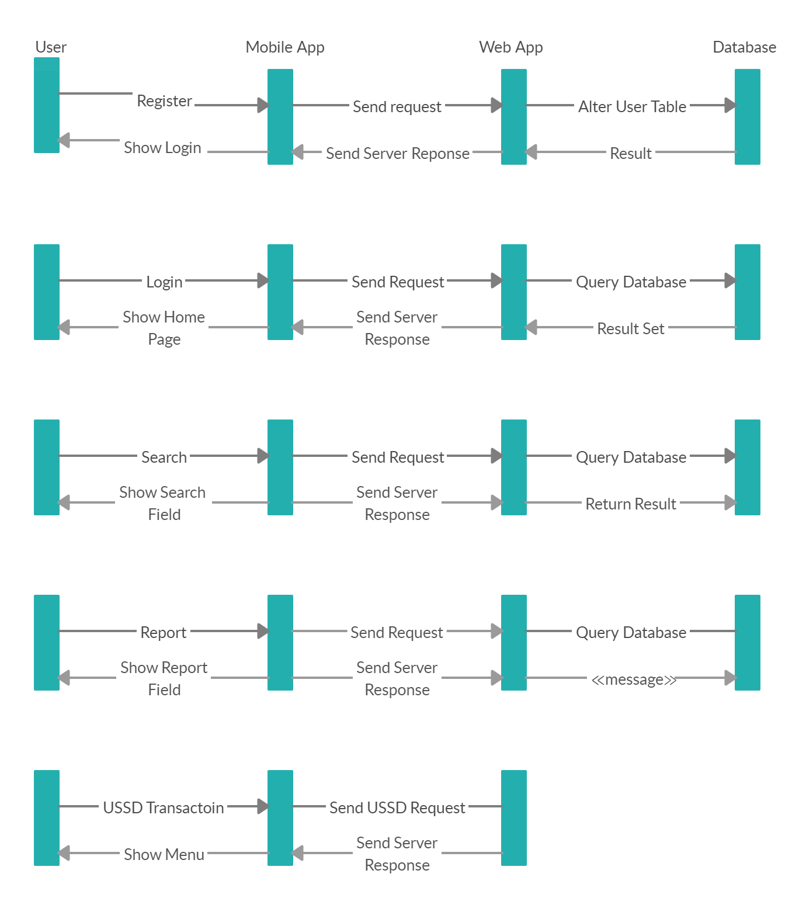

### USE-CASE DIAGRAM

FIGURE4.2: Identifies the use case diagram, the interactions between the system and the users.

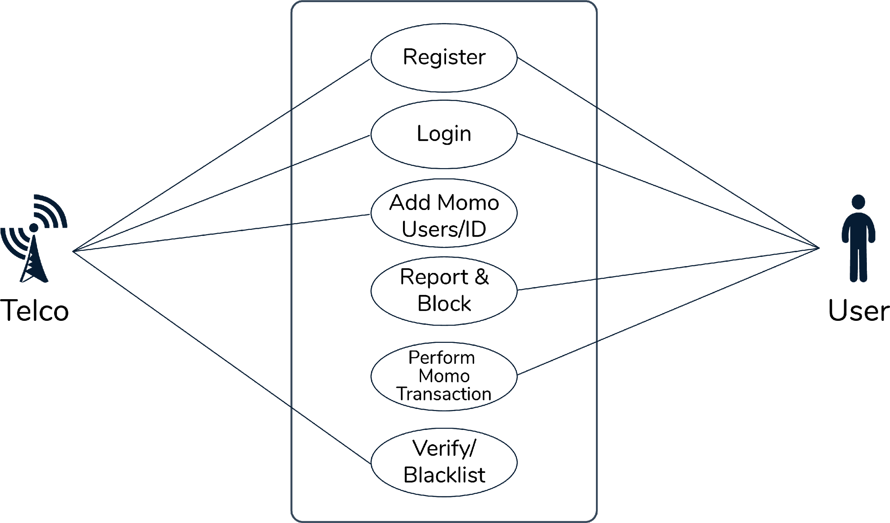

## 

## DESIGN CONSIDERATION AND SELECTION

To implement the desired system, we had to make a choice of the tools and material to use for the various components of the project.

### SERVER

We selected the nginx as the server to use. We picked it over its competitor apache2 because it performs 2.5 times faster than apache2 according to benchmark[[13]](https://www.zotero.org/google-docs/?uy8TcE). It also offers better security.

### WEB APPLICATION

We selected the Laravel Framework for the web application. This will be the main backend of the system and all other components will interact with it.

### MOBILE APPLICATION

For the mobile application, we decided to choose the Flutter Framework for mobile development. It allows us to write one code base that compiles to native code on the various platforms. The flexibility is that application logics that are not supported by default, can be written in the respective platform code.

### CACHE

We selected Redis as the cache storage. This is because it is the fastest object storage in the world at this moment. Allowing for quicker access time.

### DATABASE

For the database, we selected PostgreSQL. It is the world's most advanced database. It allows us to move complex data manipulation to the database so that the application can run much faster.

## DATABASE MODELLING

The various entity in the database includes Users which can be subdivided into SuperAdmin, Admin, Registrar, and Subscriber. A User can be linked to a Telco. This is done for Admin and Registrar to associate them with the Telco.

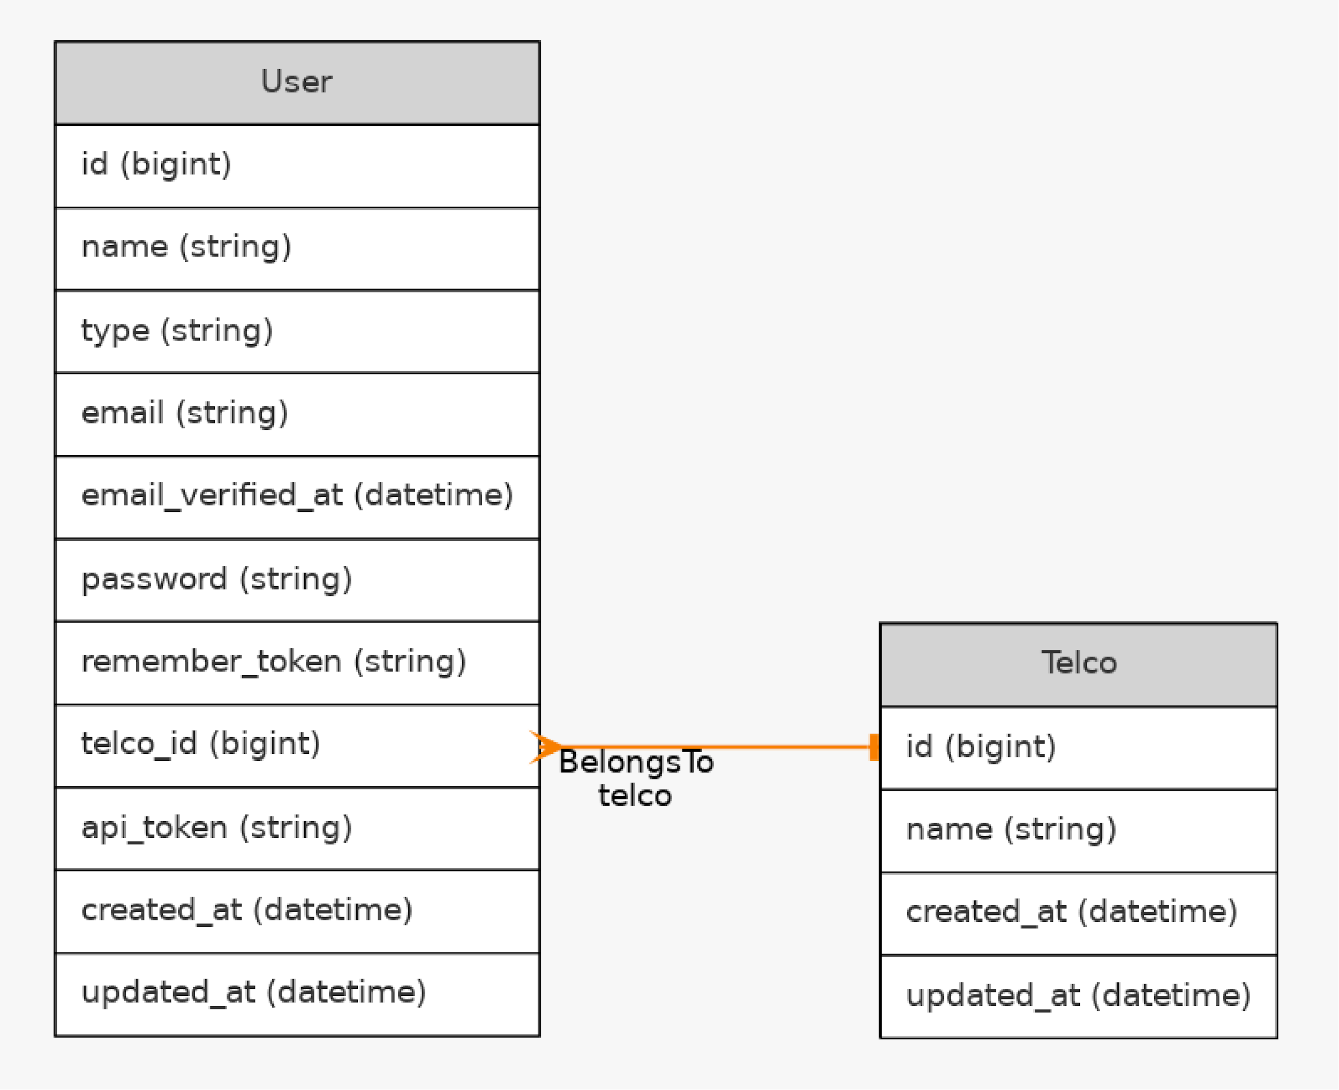

Users are divided into Subscribers, the people using the mobile application, Super Admin the one which manages the company, Registrar the people to enter information and Admin, the ones who manage Telco.

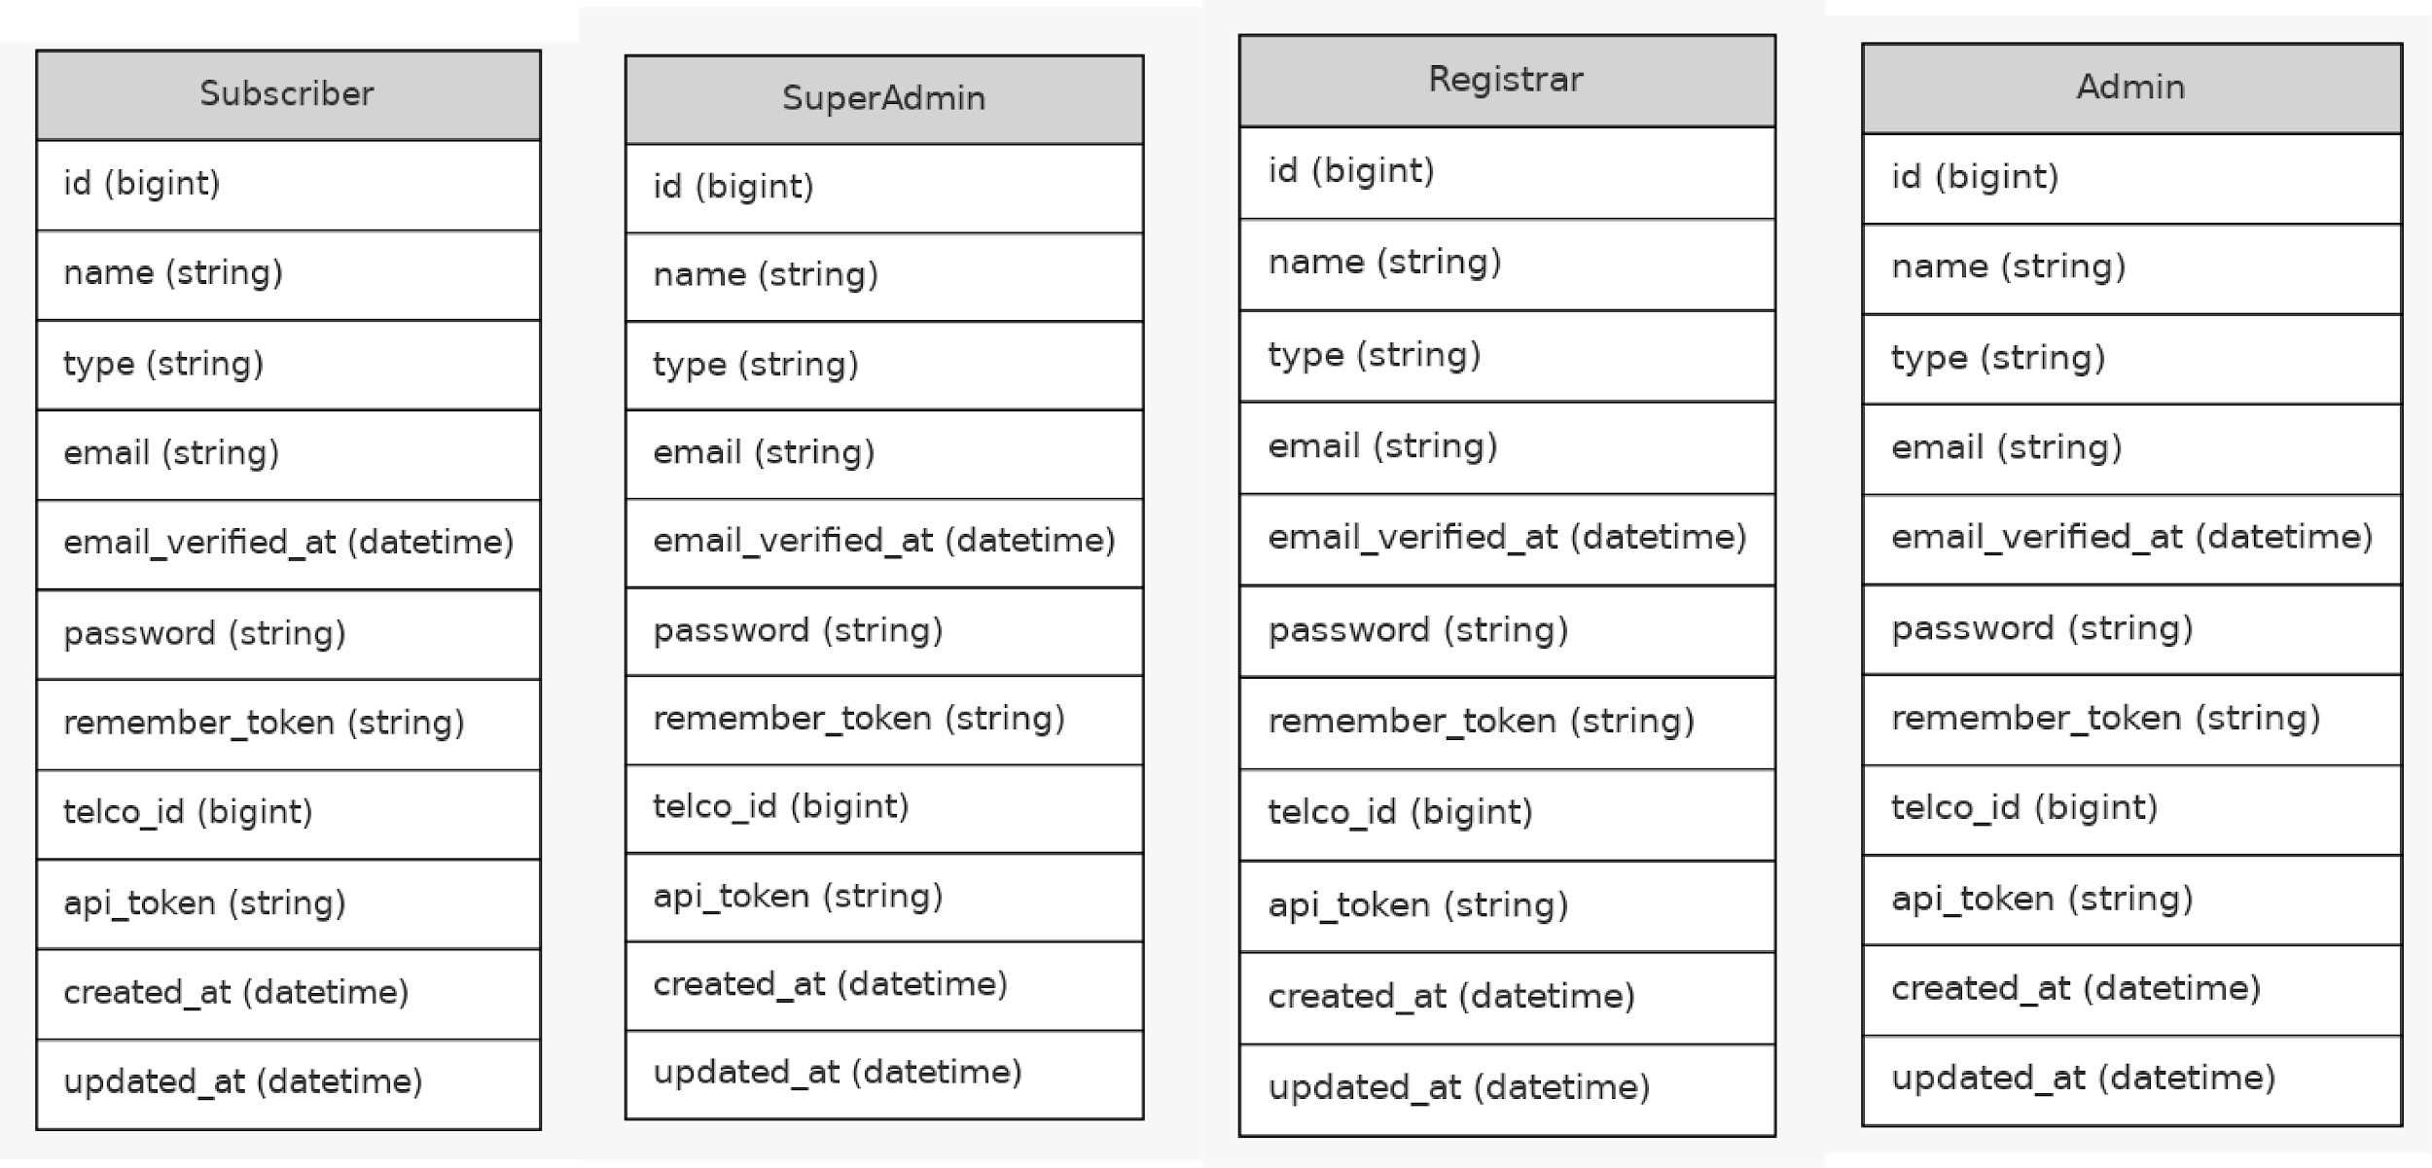

There is a Report Entity to keep track o all reports

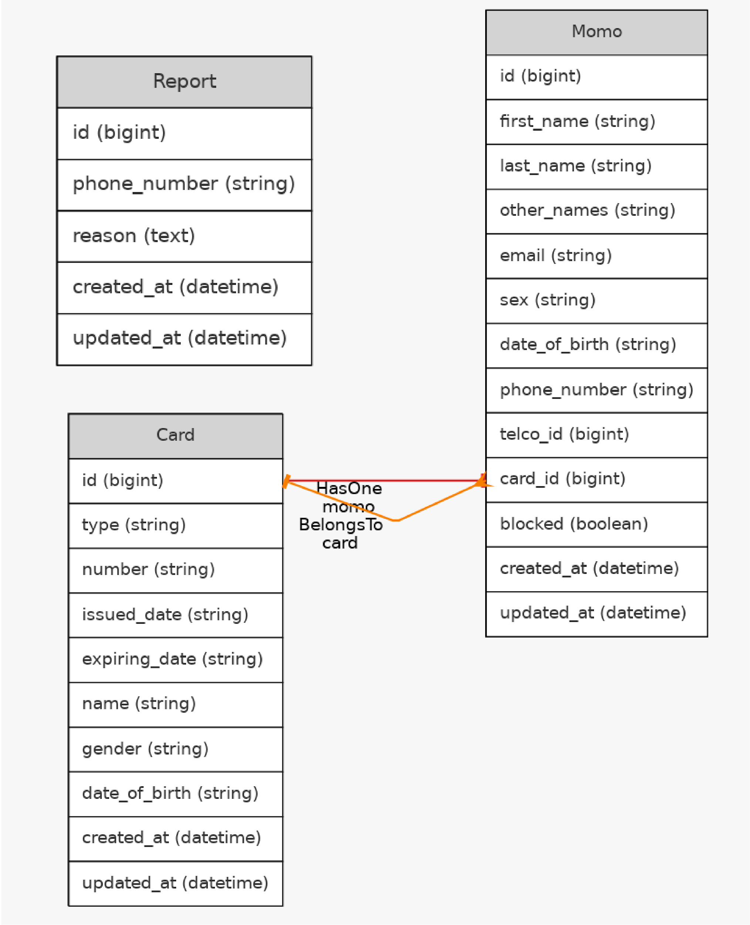

## DEVELOPMENT TOOLS

When working on the project, it would not have been possible without the following tools. These tools helped to make the project a reality and in addition, it made it convenient to implement the necessary logics.

### GIT

Git is a free, open-source version control system designed for managing anything from small to very large projects with speed and productivity[[14]](https://www.zotero.org/google-docs/?3fkYhF). It the world-leading version control. We used git to manage the collaboration without causing conflicts during development.

### GITHUB

Github is a platform for creation that is inspired by how you function. You can host and review code from open source to market, manage projects, and build software alongside 50 million developers[[15]](https://www.zotero.org/google-docs/?jHyzcY). It the most used development platform. We used GitHub to save a remote copy of the project and to allow remote collaboration.

### ADOBE ILLUSTRATOR

Adobe Illustrator is a software application that uses a Windows or macOS computer to create drawings, illustrations, and artworks. Originally published in 1987, Illustrator continues to be updated at regular intervals and is now part of the Adobe Creative Cloud[[16]](https://www.zotero.org/google-docs/?UG0ypJ). We used it to create all graphic images, designs, and illustrations in this project.

### POSTGRESQL

PostgreSQL is a strong, open-source object-relational database system with more than 30 years of active development that has earned it a solid reputation for reliability, robustness, and performance[[17]](https://www.zotero.org/google-docs/?CpBHGB). We used this for data storage and retrieval as well as other data manipulations.

### ANDROID

Android is a mobile operating system based on a modified version of the Linux kernel and other open-source software primarily designed for mobile devices such as smartphones and tablets on the touch screen. Android is being developed by a group of developers known as the Open Smartphone Alliance and funded by Google commercially[[18]](https://www.zotero.org/google-docs/?VgCKtz). The mobile application was tested on an android based device.

### IOS

iOS (formerly iPhone OS) is a mobile operating system designed and built exclusively for your hardware by Apple Inc. It's the operating system that controlled many of the company's mobile devices, including the iPhone and iPod Touch; it also controlled the iPad before the 2019 iPadOS was launched. It is the second most commonly deployed mobile operating system in the world, after Android[[19]](https://www.zotero.org/google-docs/?iCLsw5). Although the mobile application supports IOS devices, no test was run on it.

### FLUTTER

Flutter is Google's UI toolkit designed to create beautiful, natively compiled mobile, web, and desktop applications from a single codebase[[20]](https://www.zotero.org/google-docs/?Z8I2pN). With Flutter we were able to build a mobile application that supports Android and IOS, which was native to the respective OSes.

### ANDROID STUDIO

Android Studio is the official Integrated Development Environment ( IDE) based on IntelliJ IDEA for Android device development. In addition to the powerful code editor and developer tools from IntelliJ, Android Studio provides many more features that improve your productivity when creating Android apps. It as plugins for Flutter that make building for both IOS and Android simple.

### PHP

PHP (recursive acronym for PHP: Hypertext Preprocessor) is a commonly used general-purpose open-source scripting language that is particularly suited for Web development and can be embedded in HTML[[21]](https://www.zotero.org/google-docs/?87cBQ2). This was the language used for the web application.

### NGINX

NGINX is open-source Web server tech, reverse proxy, caching, load balancing, media sharing, and more. It started as a web server designed to deliver maximum performance and stability. NGINX can also act as an email proxy server (IMAP, POP3, and SMTP), as well as a reverse proxy and load balancer for HTTP, TCP, and UDP servers in addition to its HTTP server capabilities[[22]](https://www.zotero.org/google-docs/?Y7po0v). This was the server used to run the application

### MAIL CATCHER

Mail Catcher runs a super simple SMTP server that catches any message sent to it to display in a web interface[[23]](https://www.zotero.org/google-docs/?bUdVuA). This allows testing application logic without having to create multiple emails or bombard friends and family with email before begin able to test.

### LARAVEL

Laravel is a web application framework with an expressive and elegant syntax[[24]](https://www.zotero.org/google-docs/?hk20ae). It focuses on simplicity with a well-laid foundation, allowing you to create web applications without sweating the small things. We used this to build web applications and APIs.

### LARAVEL LIVEWIRE

Livewire is a full-stack framework for Laravel that makes building dynamic interfaces simple, without leaving the comfort of Laravel[[25]](https://www.zotero.org/google-docs/?dpy4Rp). It uses a technology known as server-rendered partials to make this possible. This was used to make the image upload to the server, processing by the AI script and displaying the result interactive at run time.

### JAVASCRIPT

JavaScript is a scripting or programming language that allows you to implement complex features on web pages such as displaying timely content updates, interactive maps, animated 2D/3D graphics, scrolling video jukeboxes, etc[[26]](https://www.zotero.org/google-docs/?qelBlS). User interaction was handled by this language.

### ALPINE JS

Alpine.js offers you the reactive and declarative nature of big frameworks like Vue or React at a much lower cost. This made the use of JavaScript super easy.

### CASCADING STYLE SHEETS (CSS)

Cascading Style Sheets, nicknamed CSS, is a simple design language intended to simplify the process of making presentable web pages[[27]](https://www.zotero.org/google-docs/?QZ60P5). CSS handles a web page's look and feel. Use CSS, you can monitor text color, font type, paragraph spacing, how columns are spaced and laid out, what background images or colors are used, layout designs, display variations for various devices and screen sizes, and a number of other effects.

### TAILWIND CSS

Tailwind CSS is a highly customizable, low-level CSS framework that gives you all the building blocks you need to create tailor-made designs without overriding any distracting, opinionated styles[[28]](https://www.zotero.org/google-docs/?5sZ4sA). Using Raw CSS can be a pain, but thanks to Tailwind CSS, designing a beautiful site becomes just a thought.

### HERO ICONS

For your marketing website, hero icons are a unique collection of icons that make it easy to customize with CSS to better fit with your brand. Icons bring illustrations into web applications.

### VISUAL STUDIO CODE

Visual Studio Code is a lightweight but powerful source code editor for Windows, macOS, and Linux that runs on your desktop. This comes with JavaScript, TypeScript, and Node.js built-in support and has a vast ecosystem of plugins for other languages ( such as C++, C #, Java, Python, PHP, Go) and runtimes (such as. NET and Unity)postman[[29]](https://www.zotero.org/google-docs/?LmFK3Z). This editor was used in web application development. And sometimes for the mobile application.

### POSTMAN

Postman is a tool for software development. This helps people to test API calls. Users of the postman enter their details. The data is sent to a particular address of the Web server. Usually, the information that the web server returns is presented to the user.

### PYTHON

Python is a powerful, multi-purpose programming language. It fast and plays well with other languages. It open-sourced and runs everywhere.

### ANACONDA

Anaconda is the most popular Python distribution platform in the world, with over 20 million users around the world[[30]](https://www.zotero.org/google-docs/?vUk9GG). You can count on its long-term dedication to supporting the Anaconda open-source community, Python's data science platform of choice.

### JUPYTER NOTEBOOK

The Jupyter Notebook is an open-source web application that enables you to create and share live code, equations, visualizations, and narrative text documents[[31]](https://www.zotero.org/google-docs/?JNGOKi). Uses include data cleaning and transformation, computational simulation, mathematical modeling, machine learning, data visualization, and many more.

### TENSORFLOW

TensorFlow Federated (TFF) is an open-source framework for machine learning and other computations on decentralized data. TFF has been developed to facilitate open research and experimentation with Federated Learning (FL), an approach to machine learning where a shared global model is trained across many participating clients that keep their training data locally[[32]](https://www.zotero.org/google-docs/?tLwEuU).

### TESSERACT

Tesseract is an OCR (Open Source Text Recognition) Engine, available under license Apache 2.0. It can be used directly, or (for programmers) to extract printed text from images using an API.

### OPEN COMPUTER VISION (OPEN CV)

OpenCV ( Open Source Computer Vision Library) is an open-source computer vision and software library for machine learning. OpenCV was built to provide a common computer vision infrastructure and to accelerate the use of machine perception in commercial products. Being a BSD-licensed product, OpenCV makes use and modification of the code easy for businesses[[33]](https://www.zotero.org/google-docs/?sv2Y6z).

# IMPLEMENTATION AND TESTING

## INTRODUCTION

This chapter discusses the results of testing the project. This is done to ensure that the initial objectives set out for the projects are met.

## IMPLEMENTATION AND TESTING

The implementation process for the various sections of the Fraud Alert System is divided into the mobile application and web application. The mobile application process will be evaluated first, followed by the web application.

### MOBILE APPLICATION SUBSYSTEM

#### REGISTRATION

The registration focused on simplicity to avoid user frustration. The name, email, and password are the details collected as shown in the figure below. Three input fields and a button is used to get the information. When the button is pressed, the data is sent to the web application using the HTTP protocol. The web application validates the data to enough users can not register multiple times with the same email. When the data is valid, it saved in the database and a JSON created response with 201 status is returned. The mobile application shows a snack bar with a successful response or displays the error is any occurred.

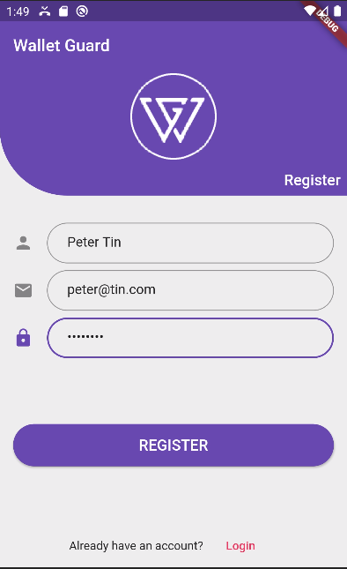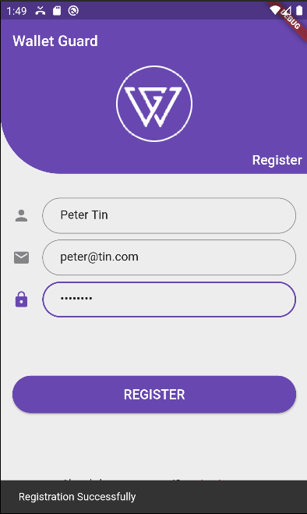

#### LOGIN

To login, only the unique email and password are required. Two input fields are provided with a button. When the button is pressed the data in the field is validated for first-hand correctness before sending the request to the server using the HTTP protocol.

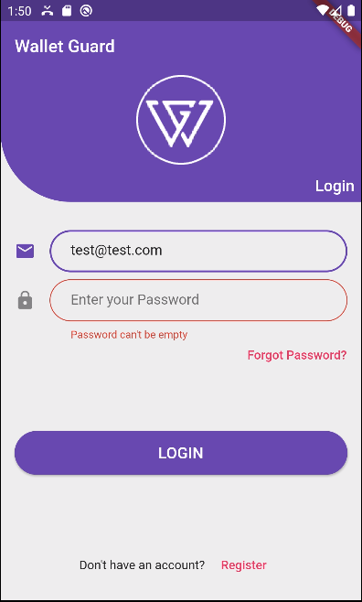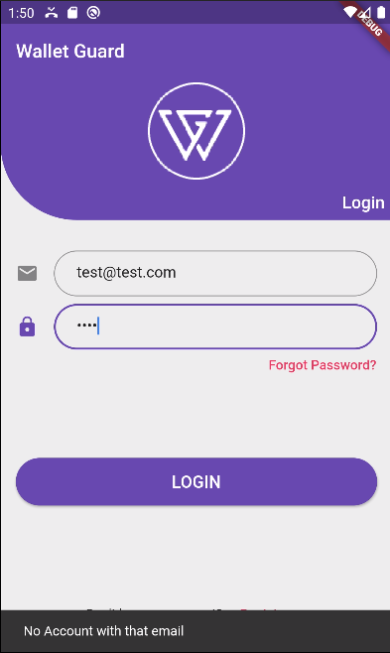

The server checks for second-hand correctness of the data. When there is an error, it returns the error message with status 422. But when the user credentials are valid, a token is returned with the request with status 200. The mobile application displays the error if any, but when the authentication was successful, it saves the token in the application settings and navigates the user to the home page.

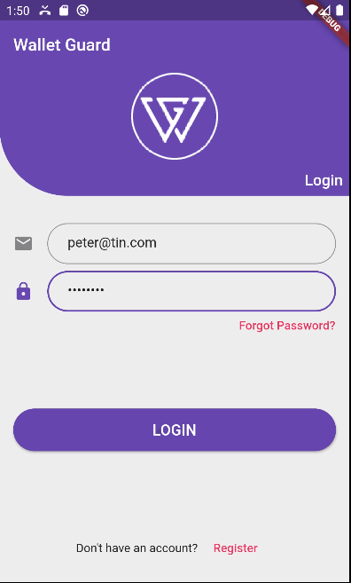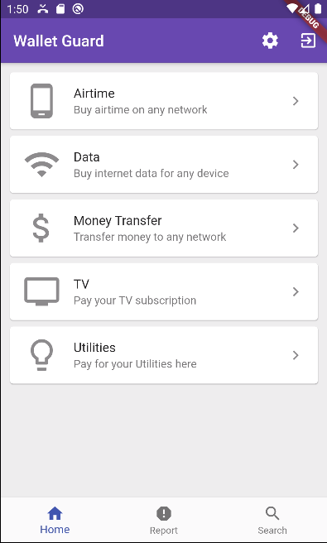

#### REPORTING

Subscribers are provided with a quick but simple interface to make reports in the report tab. They provide the fraudster number and the reason or additional comments. After that, they press the report button. The data is then sent to the web applications so that administrators are notified quickly to investigate and perform the necessary action. The feedback of the report is shown to the user using a snack bar.

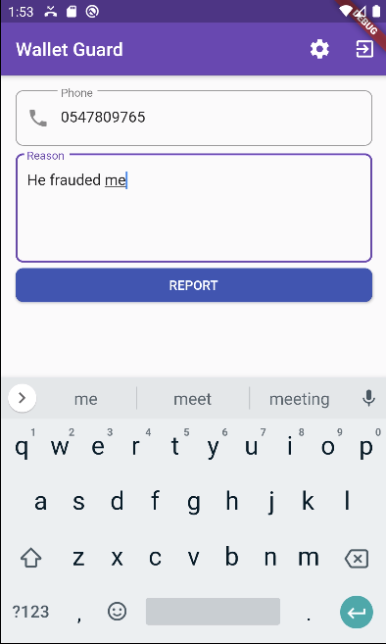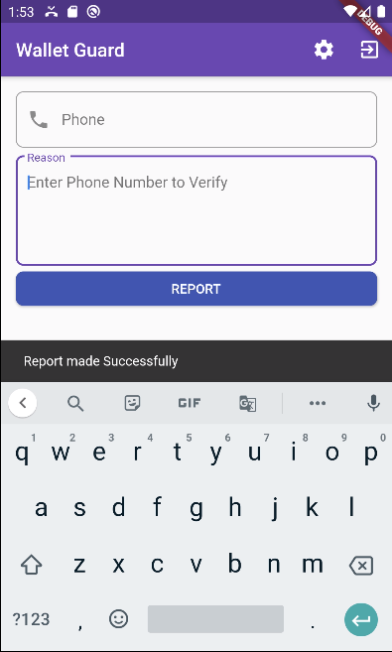

#### SEARCHING

Subscribers can quickly search for the status of a mobile money user in the search tab. This feather is to allow them to use the application to verify phone numbers they have received a call from on a different phone with does not have the application or to help a friend or family. They are provided with an input field and a search button.

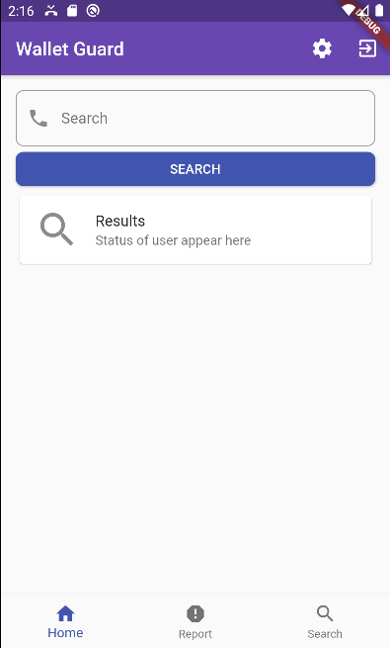

The result for the number will be displayed after the mobile application makes a request to the web application and receives the status.

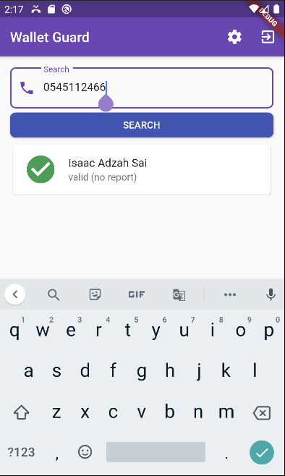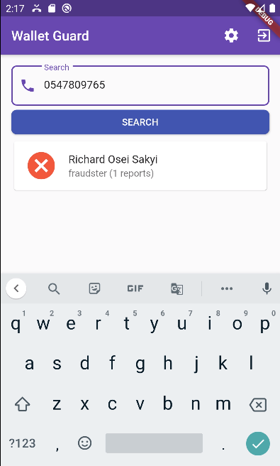

#### REALTIME NUMBER VALIDATION

It also possible for the application to do a realtime number validation. When the subscriber logs in for the first time, a background service is started that registers a broadcast receiver. A broadcast receiver is a component of mobile application that lets applications know of external affairs. This will enable the mobile application to know of incoming calls and react to them. When an incoming call is deterred, an HTTP call is made to the web application with the phone number of the incoming calls. The web application return a JSON response indicating the status of the caller with reasons. The mobile application then displays it to the user in order to alert him or her.

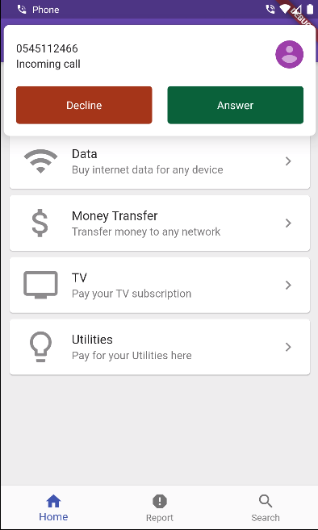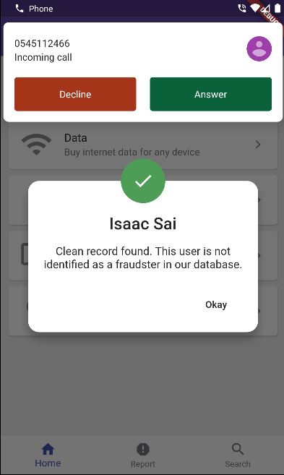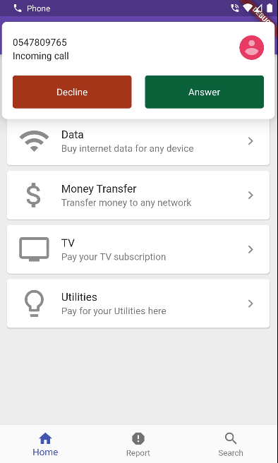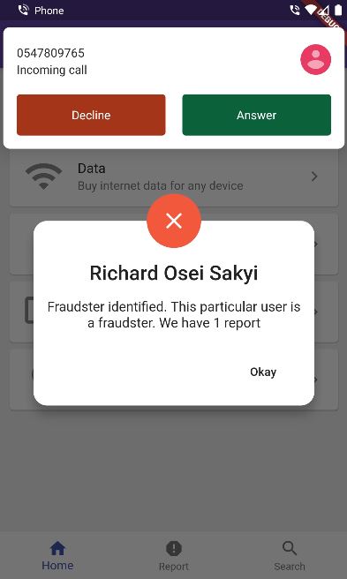

### WEB APPLICATION SUBSYSTEM

#### SUPER ADMIN CONSOLE

The web application does not have a register feature. This is to prevent unauthorized people from getting access to the administration. The only way to have the first authorized user is to use the developed console. This is protected by the ssh key which makes it difficult to be hacked. The super admin follows the interactive console and provides the needed information. He is then added with the super admin privileges.

He can then login and perform his roles.

#### ADD TELCO

The first role of the super admin is to add telecommunication networks (Telcos). Telcos Group the various users on the platform. After login in. He can click on the add telco button.

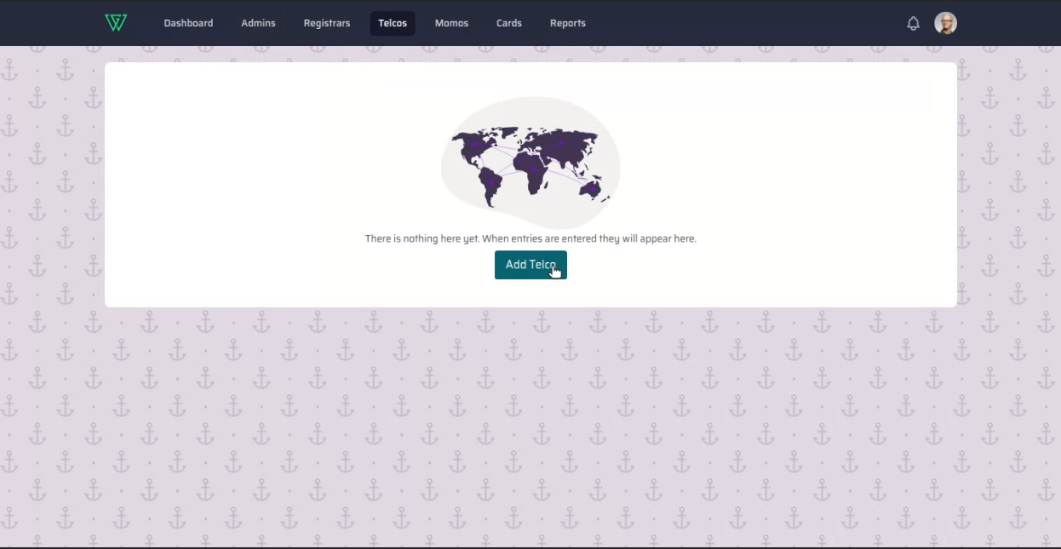

The then fills the form and submits for the telco to be added.

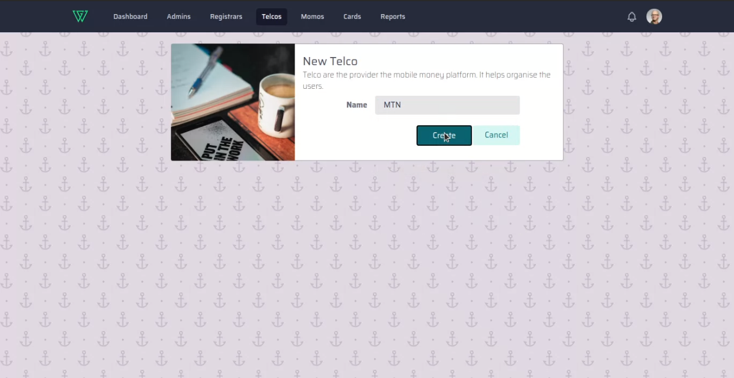

The page redirects to the list of telcos after successfully adding the telco.

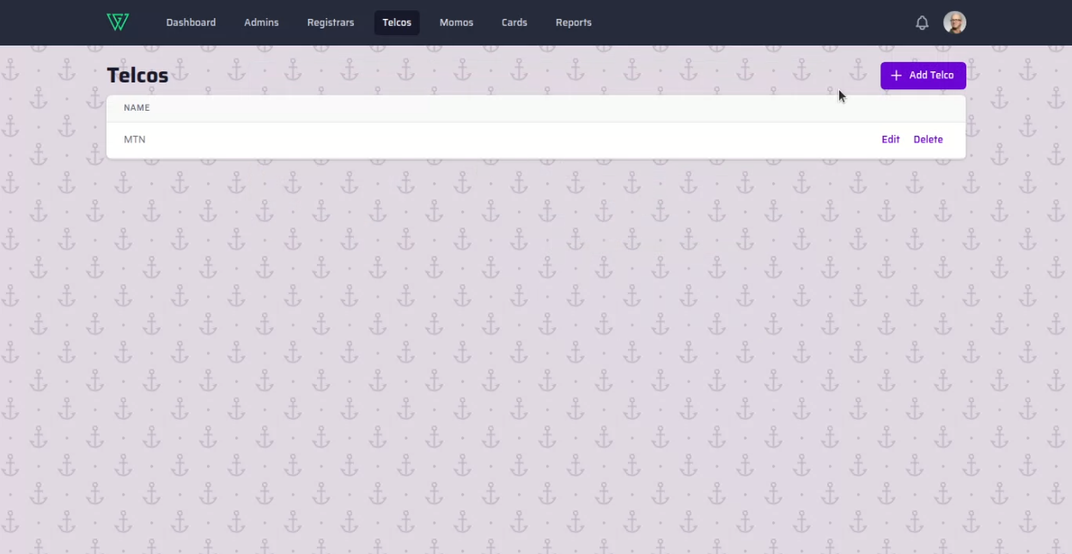

#### ADD ADMIN

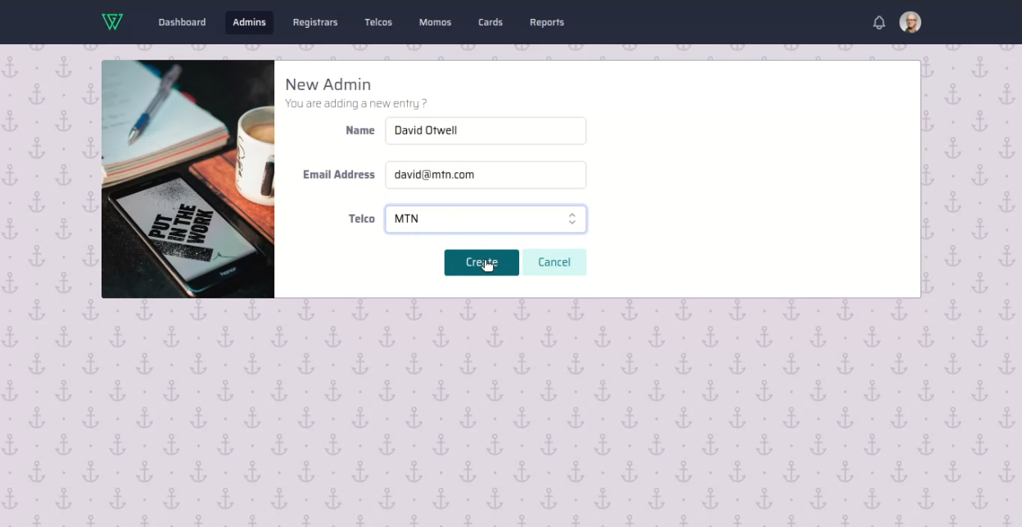

Administrators are next to super admin. After adding the telcos, the super admin adds an administrator and assigns him to one telco. He fills the form and selects the telco to assign him to. After successful addition, the page redirects to the list of admin.

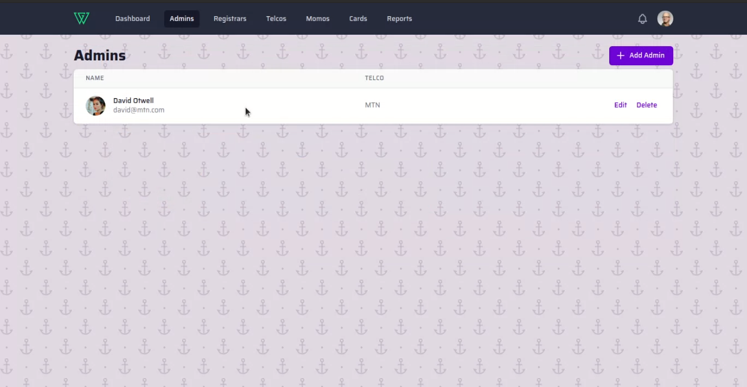

#### ADD REGISTRAR

The added admin receives an email with their auto-generated password. They can follow the link to login and add registrars. Registrars are responsible for adding mobile money users numbers and linking them to their ID card.

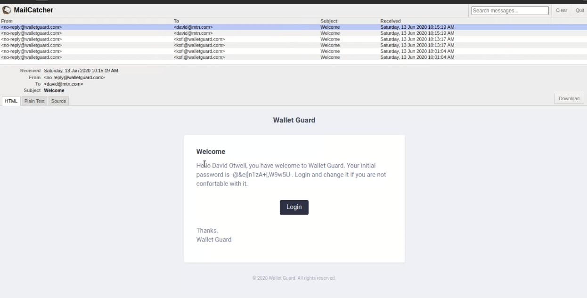

After filling the registrar’s information into the fields provided. By clicking create, they are added to the system and the admin is redirected to the list of registrars.

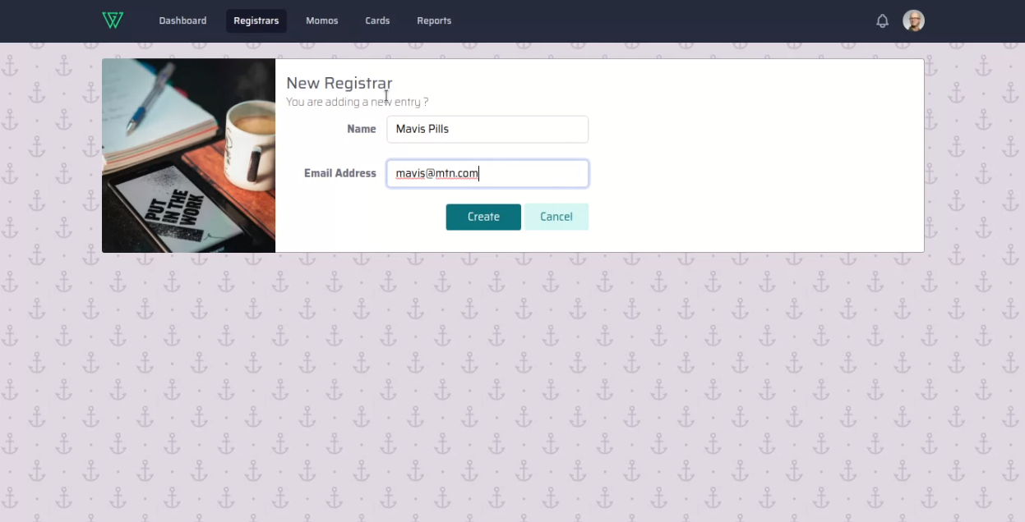

#### ADD ID CARD

Registrars receive an email with their initial password which is auto-generated. They can log in and perform their function which is to add ID cards into the system. An ID card can be added by uploading an image of it or using a camera connected with the computer.

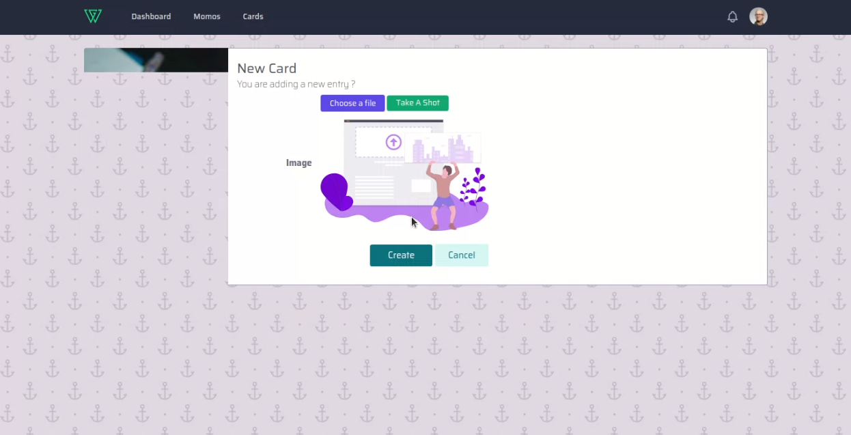

After uploading or capturing an image of the ID card, the web application calls the classification AI model as a background process to determine the type of card uploaded. When the type is identified, the web application then passes the image to the corresponding OCR model responsible for that card to extract the relevant text to fill the form. The Form is filled dynamically and the feedback is shown to the user. The Registrar can then verify the correctness and make corrections where the model did not get it right or did not fill at all.

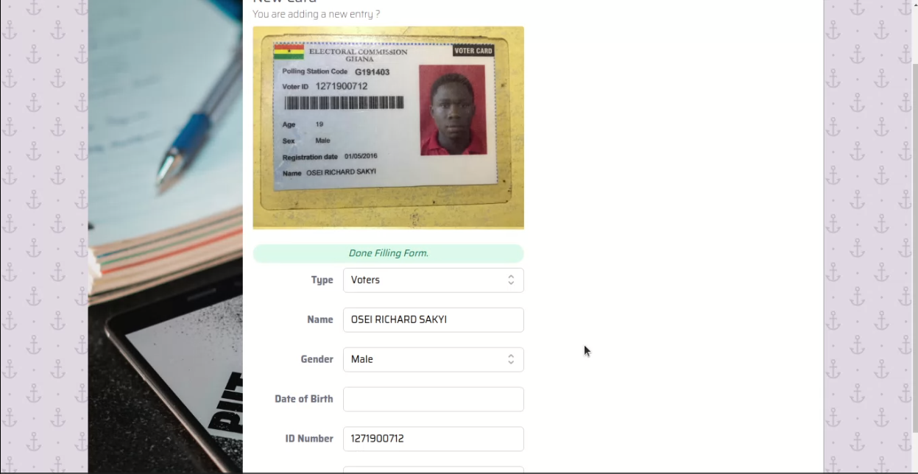

This feature allows for quicker registration and verification of ID cards. A copy of the ID is saved and can be used for further analysis in the future.

#### LINK CARD TO MOBILE MONEY NUMBER

To add a new mobile money number means their card information should have been captured already. Registrar can add a mobile number and link it to the card information. This helps to keep a profile of the user.

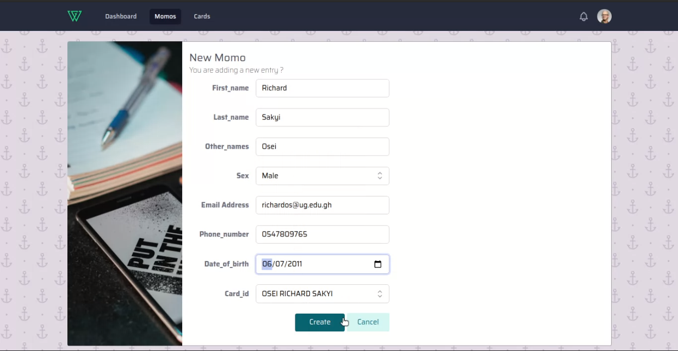

#### REVIEW REPORTS

When mobile subscribers make a report, it shows up in the web application. The Admin or Super Admin can view it and investigate the claim.

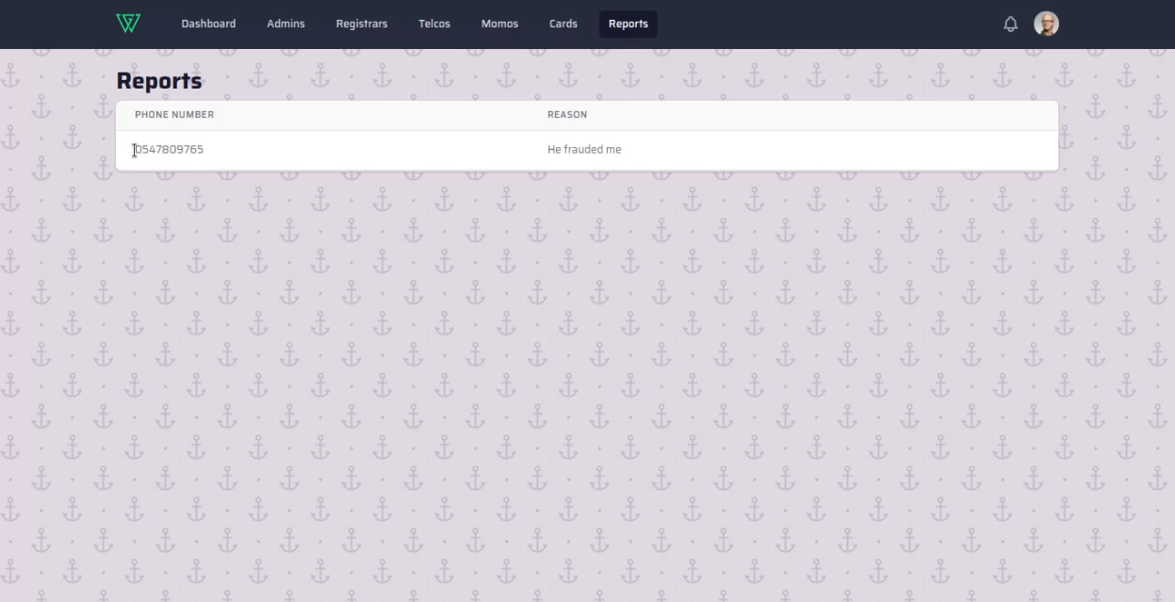

#### BLOCK USER

When a mobile money user is found guilty of commission fraud after the investigation, they can be blocked in the web application. This allows all subscribers to be notified immediately when that fraudster wants to attack them. This ensures all subscribers using the mobile application are safe.

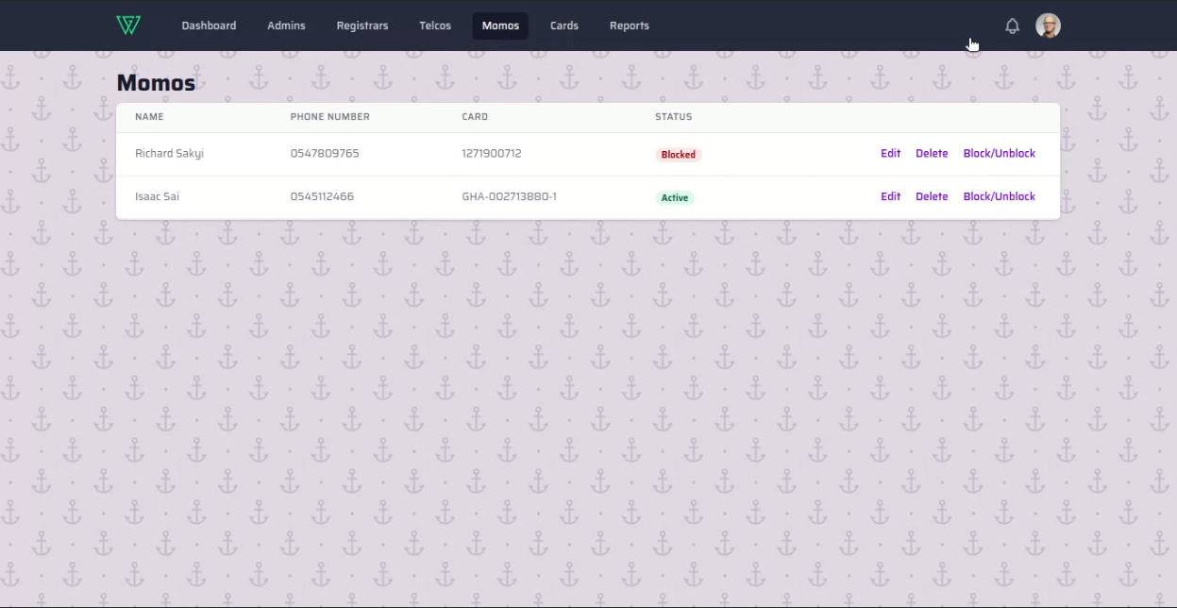

### WEB APIs FOR MOBILE APPLICATION

The mobile application has to depend on the web application for most of the functionality like registration, login and others. So this is possible, the web application exposes a RESTful API endpoint that can be used.

#### REGISTER API ENDPOINT

So the Registion API endpoint receives a json payload with the name, email and password of the subscriber.It validates to ensure the data is correct.

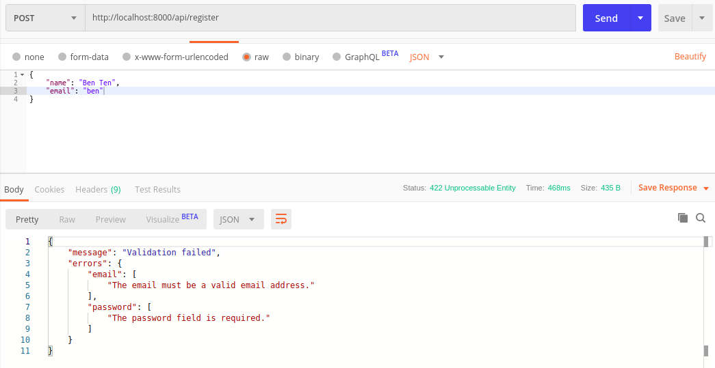

It then returns a token if successful.

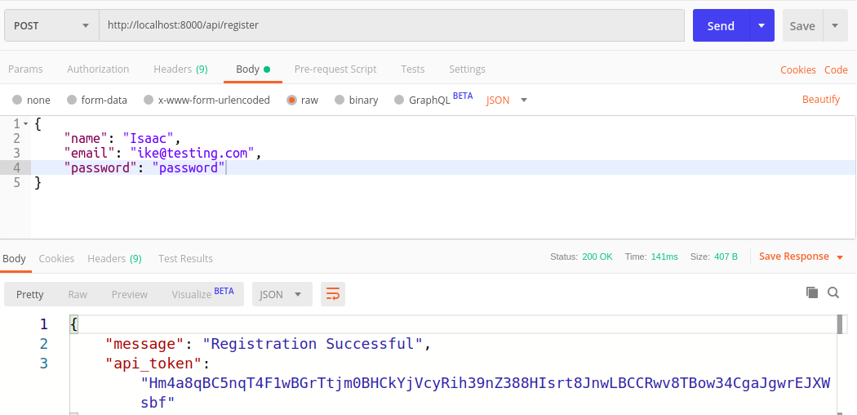

#### LOGIN API ENDPOINT

The Login Api endpoint uses basic auth to authenticate the subscriber. A request will be made with the email and password as the key for the authentication. A token is returned when successful.

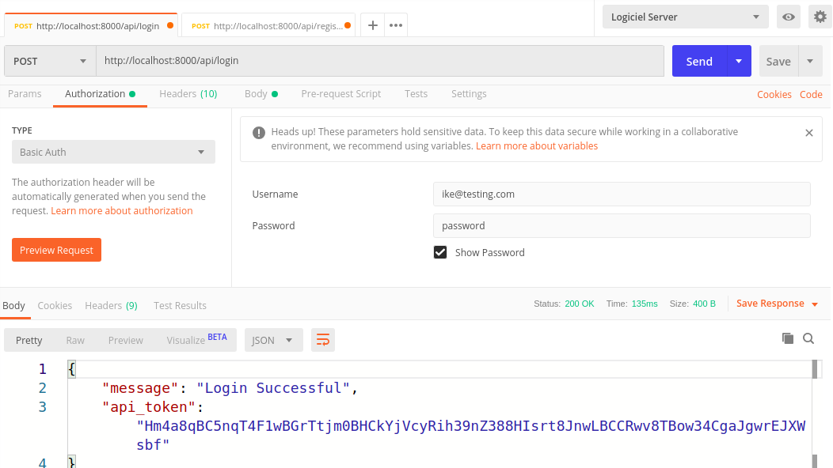

#### REPORT API ENDPOINT

To make a report, a json payload with the phone number of the fraudsters and the reason is sent. The endpoint is protected using a bearer token. So the requestor has to pass a valid token with the headers.

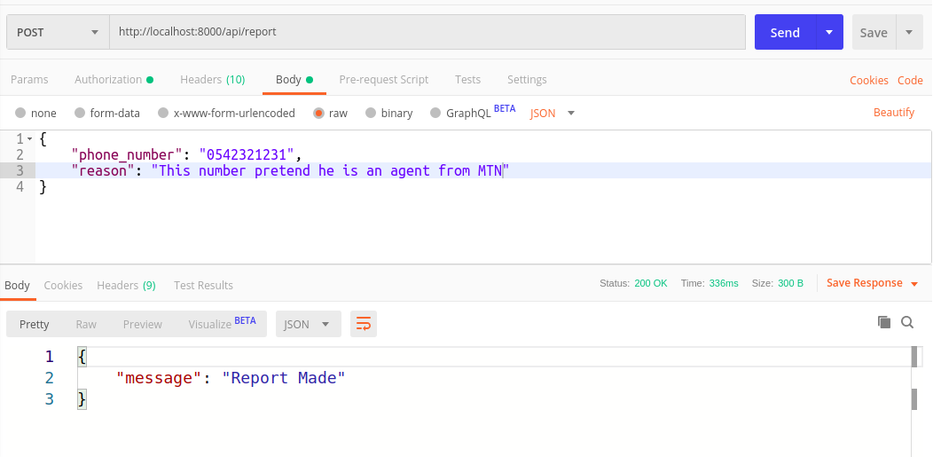

#### SEARCH API ENDPOINT

The Search endpoint allows you to look up numbers registered in the database. It is also protected by bearer token. The number to look up is passed as the payload of the JSON object.

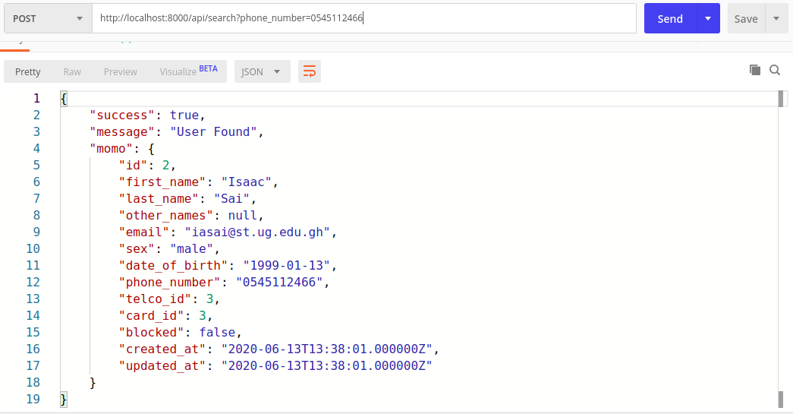

### AI MODEL

The initial development of the AI model was done on a few images to test the written code. This is because our computers could not run the code at full capacity. We had to rely on AWS Sage Maker to compile the model that was embedded into the final web application.

We start by importing the necessary library.

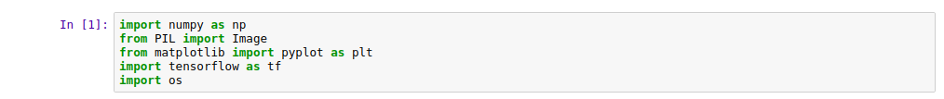

Then separating the images into training set and validation set

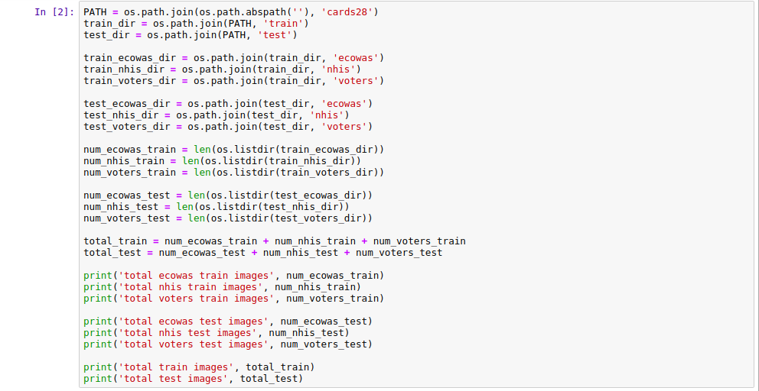

Next we preprocess the images

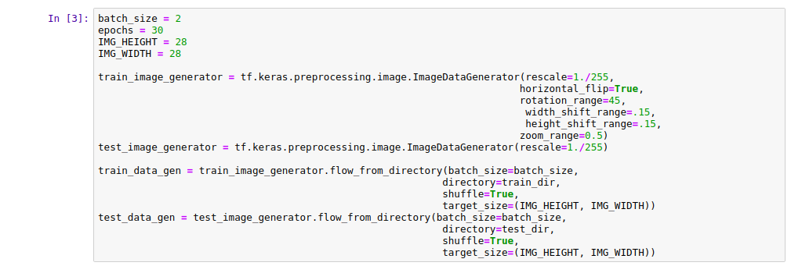

The model is then created with the Sequential function

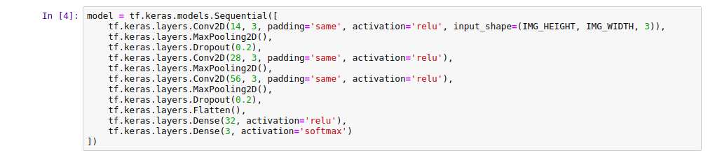

Then compiled



The summary of the resulting model is

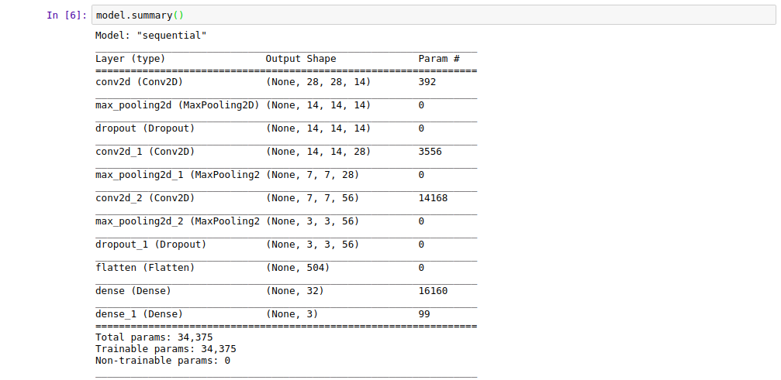

Then finally trained



The result as follows

WARNING:tensorflow:sample_weight modes were coerced from

...

to

['...']

WARNING:tensorflow:sample_weight modes were coerced from

...

to

['...']

Train for 11 steps, validate for 5 steps

Epoch 1/30

11/11 [==============================] - 2s 177ms/step - loss: 1.2068 - accuracy: 0.3810 - val_loss: 1.0970 - val_accuracy: 0.3333

Epoch 2/30

11/11 [==============================] - 0s 14ms/step - loss: 1.1520 - accuracy: 0.1905 - val_loss: 1.0763 - val_accuracy: 0.3333

Epoch 3/30

11/11 [==============================] - 0s 13ms/step - loss: 1.1290 - accuracy: 0.3333 - val_loss: 1.0765 - val_accuracy: 0.3333

Epoch 4/30

11/11 [==============================] - 0s 14ms/step - loss: 1.0926 - accuracy: 0.2857 - val_loss: 1.0818 - val_accuracy: 0.3333

Epoch 5/30

11/11 [==============================] - 0s 13ms/step - loss: 1.1081 - accuracy: 0.3333 - val_loss: 1.0715 - val_accuracy: 0.3333

Epoch 6/30

11/11 [==============================] - 0s 13ms/step - loss: 1.0884 - accuracy: 0.3333 - val_loss: 1.0639 - val_accuracy: 0.3333

Epoch 7/30

11/11 [==============================] - 0s 14ms/step - loss: 1.0858 - accuracy: 0.2857 - val_loss: 1.0696 - val_accuracy: 0.3333

Epoch 8/30

11/11 [==============================] - 0s 13ms/step - loss: 1.0981 - accuracy: 0.3810 - val_loss: 1.0522 - val_accuracy: 0.3333

Epoch 9/30

11/11 [==============================] - 0s 14ms/step - loss: 1.0688 - accuracy: 0.4286 - val_loss: 1.0606 - val_accuracy: 0.5556

Epoch 10/30

11/11 [==============================] - 0s 16ms/step - loss: 1.0573 - accuracy: 0.6190 - val_loss: 1.0439 - val_accuracy: 0.5556

Epoch 11/30

11/11 [==============================] - 0s 17ms/step - loss: 1.0162 - accuracy: 0.4762 - val_loss: 1.0250 - val_accuracy: 0.3333

Epoch 12/30

11/11 [==============================] - 0s 16ms/step - loss: 1.0033 - accuracy: 0.5238 - val_loss: 0.9634 - val_accuracy: 0.5556

Epoch 13/30

11/11 [==============================] - 0s 14ms/step - loss: 0.9065 - accuracy: 0.7619 - val_loss: 0.9274 - val_accuracy: 0.4444

Epoch 14/30

11/11 [==============================] - 0s 13ms/step - loss: 0.7768 - accuracy: 0.6190 - val_loss: 0.8333 - val_accuracy: 0.5556

Epoch 15/30

11/11 [==============================] - 0s 17ms/step - loss: 0.8252 - accuracy: 0.5714 - val_loss: 0.6858 - val_accuracy: 0.7778

Epoch 16/30

11/11 [==============================] - 0s 17ms/step - loss: 0.7788 - accuracy: 0.6190 - val_loss: 0.6286 - val_accuracy: 0.6667

Epoch 17/30

11/11 [==============================] - 0s 16ms/step - loss: 0.5628 - accuracy: 0.8571 - val_loss: 0.6006 - val_accuracy: 0.7778

Epoch 18/30

11/11 [==============================] - 0s 13ms/step - loss: 0.5725 - accuracy: 0.7619 - val_loss: 0.5342 - val_accuracy: 0.7778

Epoch 19/30

11/11 [==============================] - 0s 13ms/step - loss: 0.7449 - accuracy: 0.6190 - val_loss: 0.7062 - val_accuracy: 0.6667

Epoch 20/30

11/11 [==============================] - 0s 15ms/step - loss: 0.5870 - accuracy: 0.6667 - val_loss: 0.6314 - val_accuracy: 0.6667

Epoch 21/30

11/11 [==============================] - 0s 17ms/step - loss: 0.5515 - accuracy: 0.6667 - val_loss: 0.5855 - val_accuracy: 0.6667

Epoch 22/30

11/11 [==============================] - 0s 16ms/step - loss: 0.4680 - accuracy: 0.8095 - val_loss: 0.5395 - val_accuracy: 0.7778

Epoch 23/30

11/11 [==============================] - 0s 16ms/step - loss: 0.4429 - accuracy: 0.8095 - val_loss: 0.4941 - val_accuracy: 0.7778

Epoch 24/30

11/11 [==============================] - 0s 14ms/step - loss: 0.4228 - accuracy: 0.8095 - val_loss: 0.4789 - val_accuracy: 0.8889

Epoch 25/30

11/11 [==============================] - 0s 13ms/step - loss: 0.4057 - accuracy: 0.7619 - val_loss: 0.6552 - val_accuracy: 0.6667

Epoch 26/30

11/11 [==============================] - 0s 13ms/step - loss: 0.4889 - accuracy: 0.7143 - val_loss: 0.9180 - val_accuracy: 0.4444

Epoch 27/30

11/11 [==============================] - 0s 14ms/step - loss: 0.4666 - accuracy: 0.8095 - val_loss: 0.5428 - val_accuracy: 0.6667

Epoch 28/30

11/11 [==============================] - 0s 16ms/step - loss: 0.3839 - accuracy: 0.8571 - val_loss: 0.6064 - val_accuracy: 0.6667

Epoch 29/30

11/11 [==============================] - 0s 15ms/step - loss: 0.2728 - accuracy: 0.9524 - val_loss: 0.4898 - val_accuracy: 0.8889

Epoch 30/30

11/11 [==============================] - 0s 17ms/step - loss: 0.4395 - accuracy: 0.8095 - val_loss: 0.6311 - val_accuracy: 0.6667

The result is visualized graphically with the following code

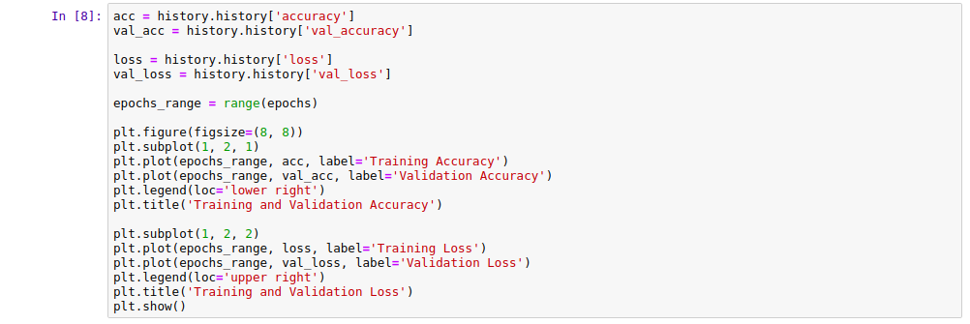

Which results in

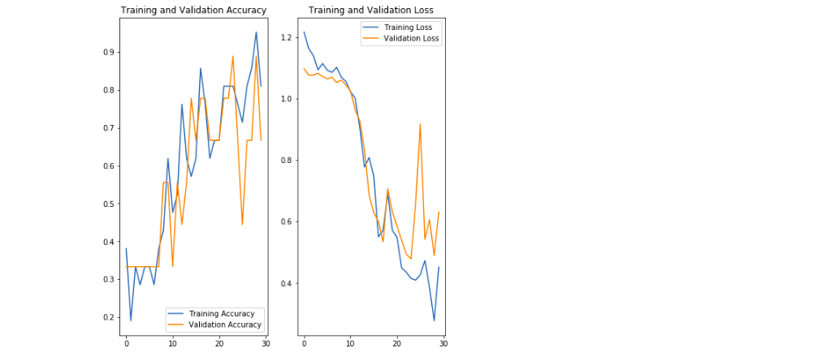

Below is a simple test of the model after training

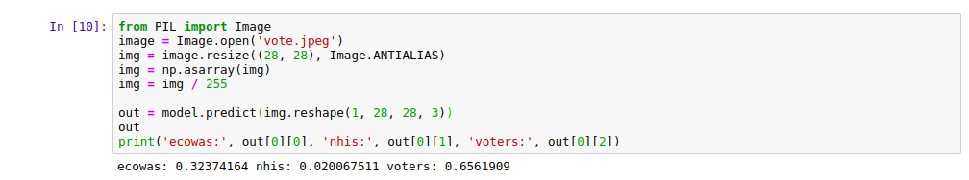

## DISCUSSION OF RESULTS AND ANALYSIS

From the results, the web application developed allows for all mobile money platforms to collaborate in fighting against fraud. It allows for the addition of any new mobile money platform. It also allows the platform to have one or more administrators to manage what happens. Furthermore, administrators can delegate registration tasks to registrars and focus on ensuring that reported cases are taken care of immediately. Registrars can quickly register new users with the help of AI models. This makes registration quite brief and easy to do. When mobile money users that have been reported are found to be guilty of the charges, they can be easily blocked and all mobile money subscribers using the mobile application will be notified immediately.

With the mobile application, mobile money subscribers can register and login to the system on any mobile device having the mobile application installed on it. They can search for the status of a number to know whether it is safe to answer their call or reply to their messages. They can also quickly report people who try to fraud them. The magic bonus is that, when they receive incoming calls, the system automatically checks the status of the caller before they even answer the call. This way, they are protected in advance.

## PERFORMANCE EVALUATION

The collaborative effects of all mobile money platforms working together to fight fraud are not captured in any existing system. The system serves as a common platform for multiple mobile money platforms to work effortlessly together. This sets the system apart. The inclusion of the AI models to speed up the registration is also not done in any system. The main benefit the system provides is realtime communication between mobile money platforms and mobile money subscribers. Immediately a fraudster is identified and block, all the users of the system have access to that information that goes a long way to protect them and their wallet from fraudsters.

# CONCLUSION AND RECOMMENDATIONS

## INTRODUCTION

In this chapter, the conclusion of the design of a fraud alert system for mobile money subscribers is stated. In addition, future recommendations are provided when anyone wants to advance the project.

## CONCLUSION

The objective of the project was to build a system that verifies user data using multiple data sources and artificial intelligence. Although both components were built, only the artificial intelligence data verification was used for demo since we did not get access to proposed data sources. For that, we had to use dummy data for testing the component feature.

The second objective was to build a TMP which was built but was not used for demo for the same reason as above. The implementation logic to build the TMP was borrowed from Advanced Web Architecture Course.

The next objective was to build a web application the helps the mobile money platform quickly register, track, and manage their users. And that was successfully completed. This was due to the ability of the classification neural network to classify the ID according to type and OCR model to extract the necessary text.

The final objective was to develop a mobile application that protected subscribers from fraudsters. That objective was also accomplished by allowing the mobile application to quickly report, search, and even use real-time incoming call verification.

Therefore, the system developed will provide enormous benefits to mobile money subscribers by alert them of fraud.

## RECOMMENDATIONS

Although the system developed provides the intended purpose, there are still recommendations that when considered, will enhance the performance of the system.

We recommend that educational videos and content be added to the next iteration of the application to help educate users of the scheme used by fraudsters.

# REFERENCES

[[1] FIBER OPTIC TECHNOLOGY AND ITS ROLE IN THE INFORMATION .... https://user.eng.umd.edu/~davis/optfib.html](FIBER%20OPTIC%20TECHNOLOGY%20AND%20ITS%20ROLE%20IN%20THE%20INFORMATION%20....%20https:/user.eng.umd.edu/~davis/optfib.html)

[[2] J. Macharia, “Mobile banking influence on wealth creation and poverty reduction for the unbanked,” in *2013 IST-Africa Conference and Exhibition, IST-Africa 2013*, 2013, pp. 1–9.](https://www.zotero.org/google-docs/?Ud5Gdm)

[[3] B. Mabrie, “The Wild West of Safeguarding Your Money: Mobile networks are at risk of being infiltrated by digital bandits.,” *IEEE Consum. Electron. Mag.*, vol. 4, no. 4, pp. 62–64, 2015, doi: 10.1109/MCE.2015.2463293.](https://www.zotero.org/google-docs/?Ud5Gdm)

[[4] A. Mugambi, C. Njunge, and S. C. Yang, “Mobile-money benefits and usage: The case of M-PESA,” *IT Prof.*, vol. 16, no. 3, pp. 16–21, 2014, doi: 10.1109/MITP.2014.38.](https://www.zotero.org/google-docs/?Ud5Gdm)

[[5] B. Seetharam and D. Johnson, “Mobile money’s impact on Tanzanian agriculture,” *IEEE Softw.*, vol. 32, no. 1, pp. 29–34, 2015, doi: 10.1109/MS.2015.12.](https://www.zotero.org/google-docs/?Ud5Gdm)

[[6] D. Sun, T. Pan, Z. Wan, and H. He, “Research of mobile E-commerce security solution based on external electronic device,” in *Proceedings - 6th International Conference on Semantics, Knowledge and Grid, SKG 2010*, 2010, pp. 355–358, doi: 10.1109/SKG.2010.58.](https://www.zotero.org/google-docs/?Ud5Gdm)

[[7] M. Zhdanova, J. Repp, R. Rieke, C. Gaber, and B. Hemery, “No smurfs: Revealing fraud chains in mobile money transfers,” in *Proceedings - 9th International Conference on Availability, Reliability and Security, ARES 2014*, 2014, pp. 11–20, doi: 10.1109/ARES.2014.10.](https://www.zotero.org/google-docs/?Ud5Gdm)

[[8] “Mobile Money fraud: Only 10% of cases prosecuted due to the use of fake IDs – Ursula,” Oct. 22, 2018. https://www.ghanaweb.com/GhanaHomePage/business/Mobile-Money-fraud-Only-10-of-cases-prosecuted-due-to-the-use-of-fake-IDs-Ursula-694600 (accessed Jul. 04, 2020).](https://www.zotero.org/google-docs/?Ud5Gdm)

[[9] “Truecaller! How it works and what you need to know about it,” *Pferanmisblog*, Sep. 17, 2019. https://pferanmi.wordpress.com/2019/09/17/truecaller-how-it-works-and-what-you-need-to-know-about-it/ (accessed Jul. 06, 2020).](https://www.zotero.org/google-docs/?Ud5Gdm)

[[10] N. U. S. in information and communication technology with a focus on VoIP, “TrueCaller App Review,” *Lifewire*. https://www.lifewire.com/truecaller-app-4047272 (accessed Oct. 04, 2019).](https://www.zotero.org/google-docs/?Ud5Gdm)

[[11] A. Krizhevsky, I. Sutskever, and G. E. Hinton, “ImageNet classification with deep convolutional neural networks,” *Commun. ACM*, vol. 60, no. 6, pp. 84–90, May 2017, doi: 10.1145/3065386.](https://www.zotero.org/google-docs/?Ud5Gdm)

[[12] P. Sarkar, H. S. Baird, and J. R. Henderson, “Systems and methods for triage of passages of text output from an OCR system,” US7171061B2, Jan. 30, 2007.](https://www.zotero.org/google-docs/?Ud5Gdm)

[[13] “Apache Vs NGINX – Which Is The Best Web Server for You?,” *ServerGuy.com*, Jan. 12, 2019. https://serverguy.com/comparison/apache-vs-nginx/ (accessed Jul. 06, 2020).](https://www.zotero.org/google-docs/?Ud5Gdm)

[[14] “Git.” https://git-scm.com/ (accessed Jul. 03, 2020).](https://www.zotero.org/google-docs/?Ud5Gdm)

[[15] “Build software better, together,” *GitHub*. https://github.com (accessed Jul. 03, 2020).](https://www.zotero.org/google-docs/?Ud5Gdm)

[[16] “What is Adobe Illustrator.” https://www.agitraining.com/adobe/illustrator/classes/what-is-adobe-illustrator (accessed Jul. 03, 2020).](https://www.zotero.org/google-docs/?Ud5Gdm)

[[17] “PostgreSQL: The world’s most advanced open source database.” https://www.postgresql.org/ (accessed Jul. 03, 2020).](https://www.zotero.org/google-docs/?Ud5Gdm)

[[18] “Android (operating system),” *Wikipedia*. Jun. 28, 2020, Accessed: Jul. 03, 2020. [Online]. Available: https://en.wikipedia.org/w/index.php?title=Android_(operating_system)&oldid=964902393.](https://www.zotero.org/google-docs/?Ud5Gdm)

[[19] “iOS,” *Wikipedia*. Jul. 01, 2020, Accessed: Jul. 03, 2020. [Online]. Available: https://en.wikipedia.org/w/index.php?title=IOS&oldid=965449616.](https://www.zotero.org/google-docs/?Ud5Gdm)

[[20] “Flutter - Beautiful native apps in record time.” https://flutter.dev/ (accessed Jul. 03, 2020).](https://www.zotero.org/google-docs/?Ud5Gdm)

[[21] “PHP: What is PHP? - Manual.” https://www.php.net/manual/en/intro-whatis.php (accessed Jul. 03, 2020).](https://www.zotero.org/google-docs/?Ud5Gdm)

[[22] “What is NGINX?,” *NGINX*. https://www.nginx.com/resources/glossary/nginx/ (accessed Jul. 03, 2020).](https://www.zotero.org/google-docs/?Ud5Gdm)

[[23] “MailCatcher.” https://mailcatcher.me/ (accessed Jul. 03, 2020).](https://www.zotero.org/google-docs/?Ud5Gdm)

[[24] “Laravel - The PHP Framework For Web Artisans.” https://laravel.com/ (accessed Jul. 03, 2020).](https://www.zotero.org/google-docs/?Ud5Gdm)

[[25] “Livewire,” *Livewire*. https://laravel-livewire.com (accessed Jul. 03, 2020).](https://www.zotero.org/google-docs/?Ud5Gdm)

[[26] “What is JavaScript?,” *MDN Web Docs*. https://developer.mozilla.org/en-US/docs/Learn/JavaScript/First_steps/What_is_JavaScript (accessed Jul. 03, 2020).](https://www.zotero.org/google-docs/?Ud5Gdm)

[[27] “What is CSS? - Tutorialspoint.” https://www.tutorialspoint.com/css/what_is_css.htm (accessed Jul. 03, 2020).](https://www.zotero.org/google-docs/?Ud5Gdm)

[[28] “Tailwind CSS - A utility-first CSS framework for rapidly building custom designs.” https://tailwindcss.com/ (accessed Jul. 03, 2020).](https://www.zotero.org/google-docs/?Ud5Gdm)

[[29] “Documentation for Visual Studio Code.” https://code.visualstudio.com/docs (accessed Jul. 03, 2020).](https://www.zotero.org/google-docs/?Ud5Gdm)

[[30] “Individual Edition,” *Anaconda*. https://www.anaconda.com/products/individual (accessed Jul. 04, 2020).](https://www.zotero.org/google-docs/?Ud5Gdm)

[[31] “Project Jupyter.” https://www.jupyter.org (accessed Jul. 04, 2020).](https://www.zotero.org/google-docs/?Ud5Gdm)

[[32] “TensorFlow Federated,” *TensorFlow*. https://www.tensorflow.org/federated (accessed Jul. 04, 2020).](https://www.zotero.org/google-docs/?Ud5Gdm)

[[33] “About.” https://opencv.org/about/ (accessed Jul. 04, 2020).](https://www.zotero.org/google-docs/?Ud5Gdm)

[[34] A. Adedoyin, “PREDICTING FRAUD IN MOBILE MONEY TRANSFER,” p. 203.](https://www.zotero.org/google-docs/?Ud5Gdm)

# APPENDICES

## CLASSIFICATION MODEL

import numpy as np

from PIL import Image

from matplotlib import pyplot as plt

import tensorflow as tf

import os

import pickle

PATH = os.path.join(os.path.abspath(''), 'cards28')

train_dir = os.path.join(PATH, 'train')

test_dir = os.path.join(PATH, 'test')

train_ecowas_dir = os.path.join(train_dir, 'ecowas')

train_nhis_dir = os.path.join(train_dir, 'nhis')

train_voters_dir = os.path.join(train_dir, 'voters')

test_ecowas_dir = os.path.join(test_dir, 'ecowas')

test_nhis_dir = os.path.join(test_dir, 'nhis')

test_voters_dir = os.path.join(test_dir, 'voters')

num_ecowas_train = len(os.listdir(train_ecowas_dir))

num_nhis_train = len(os.listdir(train_nhis_dir))

num_voters_train = len(os.listdir(train_voters_dir))

num_ecowas_test = len(os.listdir(test_ecowas_dir))

num_nhis_test = len(os.listdir(test_nhis_dir))

num_voters_test = len(os.listdir(test_voters_dir))

total_train = num_ecowas_train + num_nhis_train + num_voters_train

total_test = num_ecowas_test + num_nhis_test + num_voters_test

print('total ecowas train images', num_ecowas_train)

print('total nhis train images', num_nhis_train)

print('total voters train images', num_voters_train)

print('total ecowas test images', num_ecowas_test)

print('total nhis test images', num_nhis_test)

print('total voters test images', num_voters_test)

print('total train images', total_train)

print('total test images', total_test)

batch_size = 2

epochs = 30

IMG_HEIGHT = 256

IMG_WIDTH = 256

train_image_generator = tf.keras.preprocessing.image.ImageDataGenerator(rescale=1./255,

horizontal_flip=True,

rotation_range=45,

width_shift_range=.15,

height_shift_range=.15,

zoom_range=0.5)

test_image_generator = tf.keras.preprocessing.image.ImageDataGenerator(rescale=1./255)

train_data_gen = train_image_generator.flow_from_directory(batch_size=batch_size,

directory=train_dir,

shuffle=True,

target_size=(IMG_HEIGHT, IMG_WIDTH))

test_data_gen = test_image_generator.flow_from_directory(batch_size=batch_size,

directory=test_dir,

shuffle=True,

target_size=(IMG_HEIGHT, IMG_WIDTH))

model = tf.keras.models.Sequential([

tf.keras.layers.Conv2D(14, 3, padding='same', activation='relu', input_shape=(IMG_HEIGHT, IMG_WIDTH, 3)),

tf.keras.layers.MaxPooling2D(),

tf.keras.layers.Dropout(0.2),

tf.keras.layers.Conv2D(28, 3, padding='same', activation='relu'),

tf.keras.layers.MaxPooling2D(),

tf.keras.layers.Conv2D(56, 3, padding='same', activation='relu'),

tf.keras.layers.MaxPooling2D(),

tf.keras.layers.Dropout(0.2),

tf.keras.layers.Flatten(),

tf.keras.layers.Dense(32, activation='relu'),

tf.keras.layers.Dense(3, activation='softmax')

])

model.compile(optimizer='adam', loss='categorical_crossentropy', metrics=['accuracy'])

model.summary()

history = model.fit(train_data_gen,

epochs=epochs,

validation_data=test_data_gen)

acc = history.history['accuracy']

val_acc = history.history['val_accuracy']

loss = history.history['loss']

val_loss = history.history['val_loss']

epochs_range = range(epochs)

plt.figure(figsize=(8, 8))

plt.subplot(1, 2, 1)

plt.plot(epochs_range, acc, label='Training Accuracy')

plt.plot(epochs_range, val_acc, label='Validation Accuracy')

plt.legend(loc='lower right')

plt.title('Training and Validation Accuracy')

plt.subplot(1, 2, 2)

plt.plot(epochs_range, loss, label='Training Loss')

plt.plot(epochs_range, val_loss, label='Validation Loss')

plt.legend(loc='upper right')

plt.title('Training and Validation Loss')

plt.show()

pickle.dump(model, open('model.sav', 'wb'))

## CLASSIFICATION PREDICTION

from PIL import Image

import numpy as np

import pickle

import sys

model = pickle.load(open('model.sav', 'rb'))

image = Image.open(sys.argv[0])

img = image.resize((256, 256), Image.ANTIALIAS)

img = np.asarray(img)

img = img / 255

out = model.predict(img.reshape(1, 256, 256, 3))

out

print('ecowas:', out[0][0], 'nhis:', out[0][1], 'voters:', out[0][2])

## OCR PREPROCESSING

def get_grayscale(image):

return cv2.cvtColor(image, cv2.COLOR_BGR2GRAY)

def remove_noise(image):

return cv2.medianBlur(image,5)

def thresholding(image):

return cv2.threshold(image, 0, 255, cv2.THRESH_BINARY + cv2.THRESH_OTSU)[1]

def dilate(image):

kernel = np.ones((5,5),np.uint8)

return cv2.dilate(image, kernel, iterations = 1)

def erode(image):

kernel = np.ones((5,5),np.uint8)

return cv2.erode(image, kernel, iterations = 1)

def opening(image):

kernel = np.ones((5,5),np.uint8)

return cv2.morphologyEx(image, cv2.MORPH_OPEN, kernel)

def canny(image):

return cv2.Canny(image, 100, 200)

def deskew(image):

coords = np.column_stack(np.where(image > 0))

angle = cv2.minAreaRect(coords)[-1]

if angle < -45:

angle = -(90 + angle)

else:

angle = -angle

(h, w) = image.shape[:2]

center = (w // 2, h // 2)

M = cv2.getRotationMatrix2D(center, angle, 1.0)

rotated = cv2.warpAffine(image, M, (w, h), flags=cv2.INTER_CUBIC, borderMode=cv2.BORDER_REPLICATE)

return rotated

def match_template(image, template):

return cv2.matchTemplate(image, template, cv2.TM_CCOEFF_NORMED)

## 

## BROADCAST RECEIVER

package io.github.cybersai.walletguard;

import android.content.BroadcastReceiver;

import android.content.Context;

import android.content.Intent;

import android.telephony.PhoneStateListener;

import android.telephony.TelephonyManager;

public class PhoneStateReceiver extends BroadcastReceiver {

private static PhoneStateListener phoneStateListener;

static String EXTRA_PHONE_NUMBER;

@Override

public void onReceive(Context context, Intent intent) {

TelephonyManager telephonyManager = (TelephonyManager) context.getSystemService(Context.TELEPHONY_SERVICE);

if (telephonyManager != null && phoneStateListener == null) {

phoneStateListener = new PhoneStateListener() {

private boolean gotNewNumber = false;

private Intent intent;

@Override

public void onCallStateChanged(int state, String phoneNumber) {

super.onCallStateChanged(state, phoneNumber);

if (state == TelephonyManager.CALL_STATE_RINGING) {

intent = new Intent(context, NotificationService.class);

intent.putExtra(EXTRA_PHONE_NUMBER, phoneNumber);

gotNewNumber = true;

} else if (state == TelephonyManager.CALL_STATE_IDLE) {

if (gotNewNumber) {

try {

context.startService(intent);

gotNewNumber = false;

} catch (IllegalStateException e) {

// Could not start service

}

}

}

}

};

telephonyManager.listen(phoneStateListener, PhoneStateListener.LISTEN_CALL_STATE);

}

}

}